**DevOps Project**

**Problem Statement:**

Create an end-to-end CI/CD pipeline in AWS platform using Jenkins as the orchestration tool, GitHub as scm, maven as the build tool, deploy in a docker instance and create a docker image, store the docker image in ECR, Kubernetes deployment using ECR image. Build sample java web app using maven.

**Approach:**

**Requirements:**

✓ CI/CD pipeline System

✓ Git - local version control system.

✓ GitHub - As Distributed version control system.

✓ Jenkins - Continuous Integration tool.

✓ Maven - As a Build Tool.

✓ docker -Containerization

✓ Kubernetes - As Container Management Tool

**Step-1:**

➢ Setup CI/CD with GitHub, Jenkins, Maven & Tomcat.

➢ Setup Jenkins

➢ Setup & Configure Maven, Git.

➢ Setup Tomcat Server.

➢ Integrating GitHub, Maven, Tomcat Server with Jenkins

➢ Create a CI and CD Job.

➢ Test the Deployment

**Step-2:**

➢ Setup CI/CD with GitHub, Jenkins, Maven & Docker.

➢ Setting up the docker Environment.

➢ Create an Image and Container on Docker Host.

➢ Integrate Docker Host with Jenkins.

➢ Create CI/CD Job on Jenkins to build and deploy on container.

yum

**Step-3:**

➢ Build and Deploy on Container.

➢ CI/CD with GitHub, Jenkins, Maven & Kubernetes.

➢ Setting up the Kubernetes (EKS).

➢ Write pod service and deployment manifest file.

➢ CI/CD Job to build code on Jenkins & Deploy it on Kubernetes.

**Step-4:**

➢ Deploy artifacts on the Kubernetes

➢ Write codes in the artifacts of docker and Kubernetes which we want to run.

➢ Now build the code in Jenkins.

➢ Check in Kubernetes the pods are getting created or not.

➢ Now copy the service IP and paste it in the browser and check the output.

**Solution:**

Git-Client:

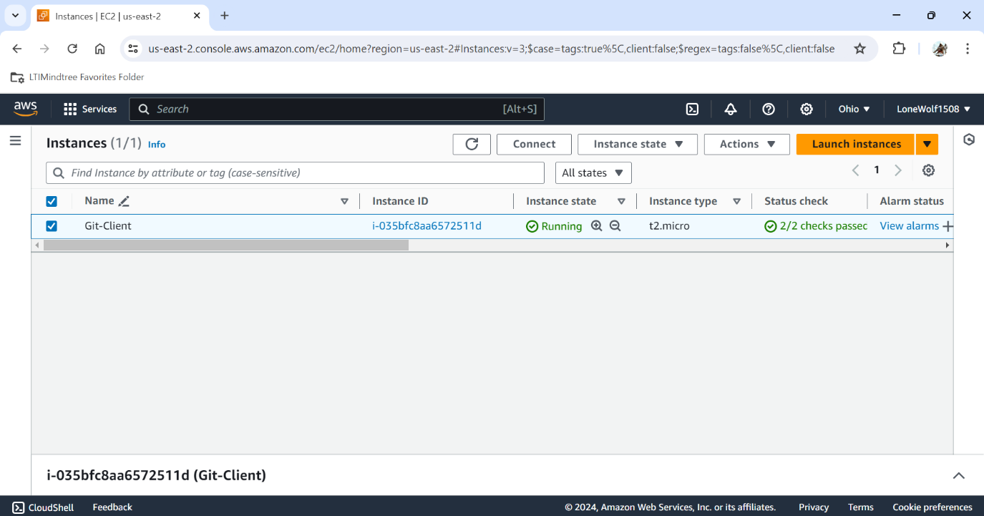

An ec2 instance is created for git operation.

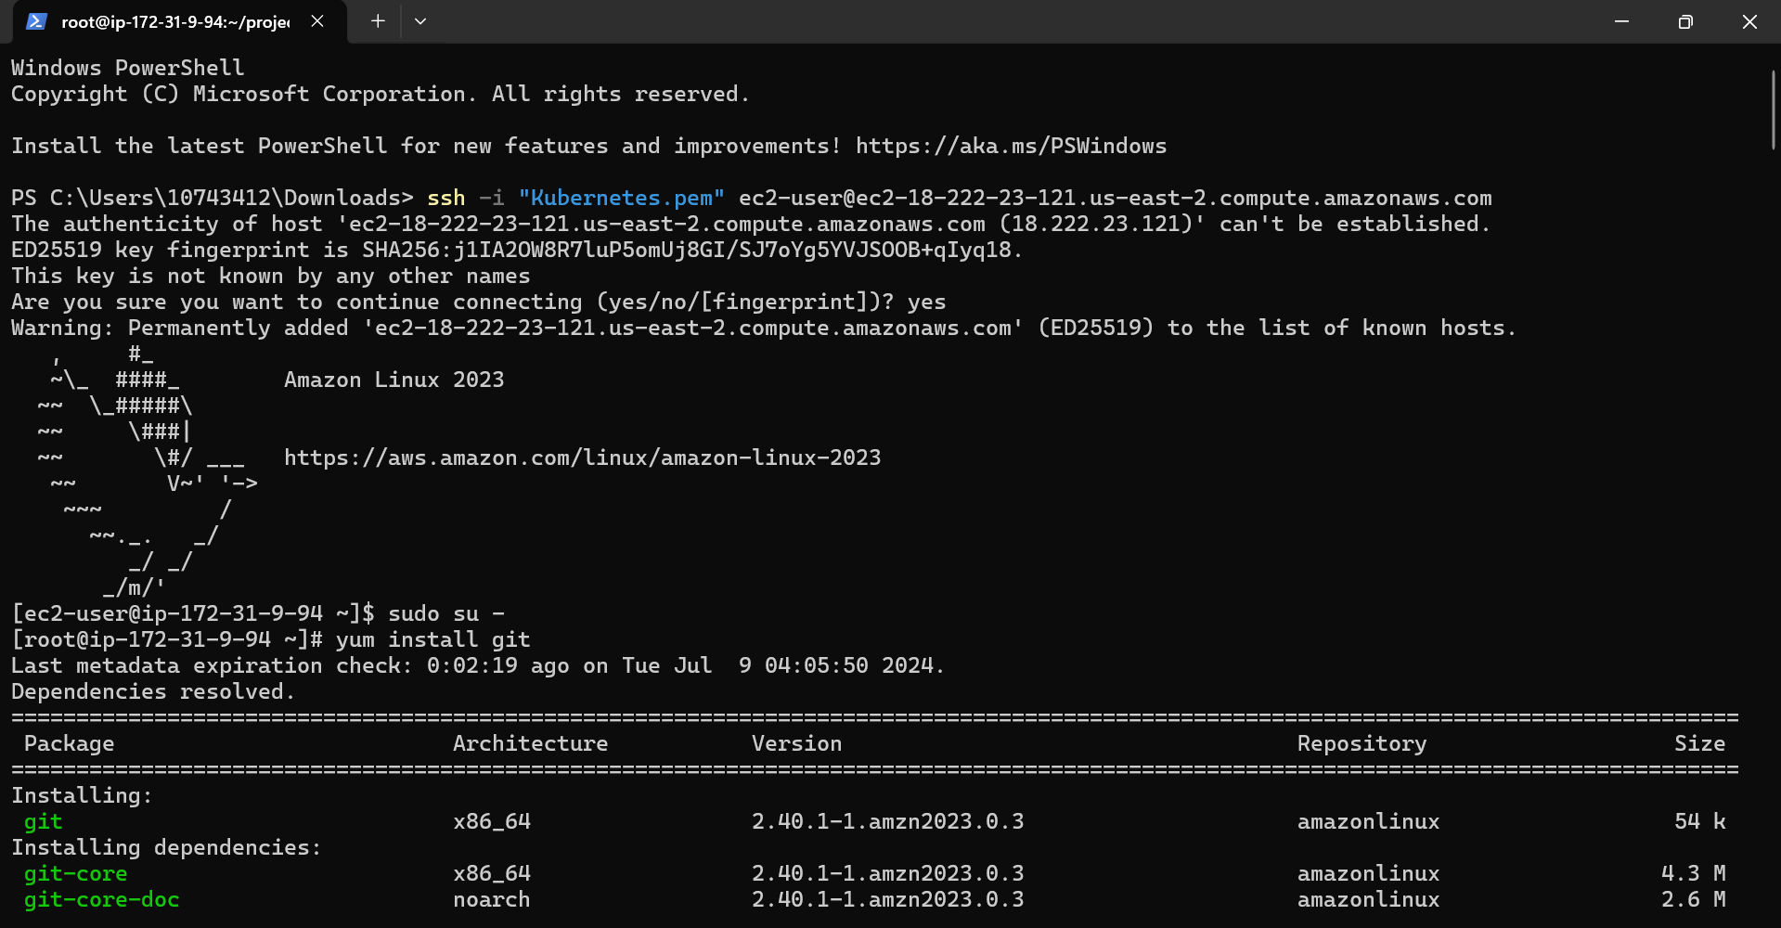

Git - Instance is connected in the Terminal.

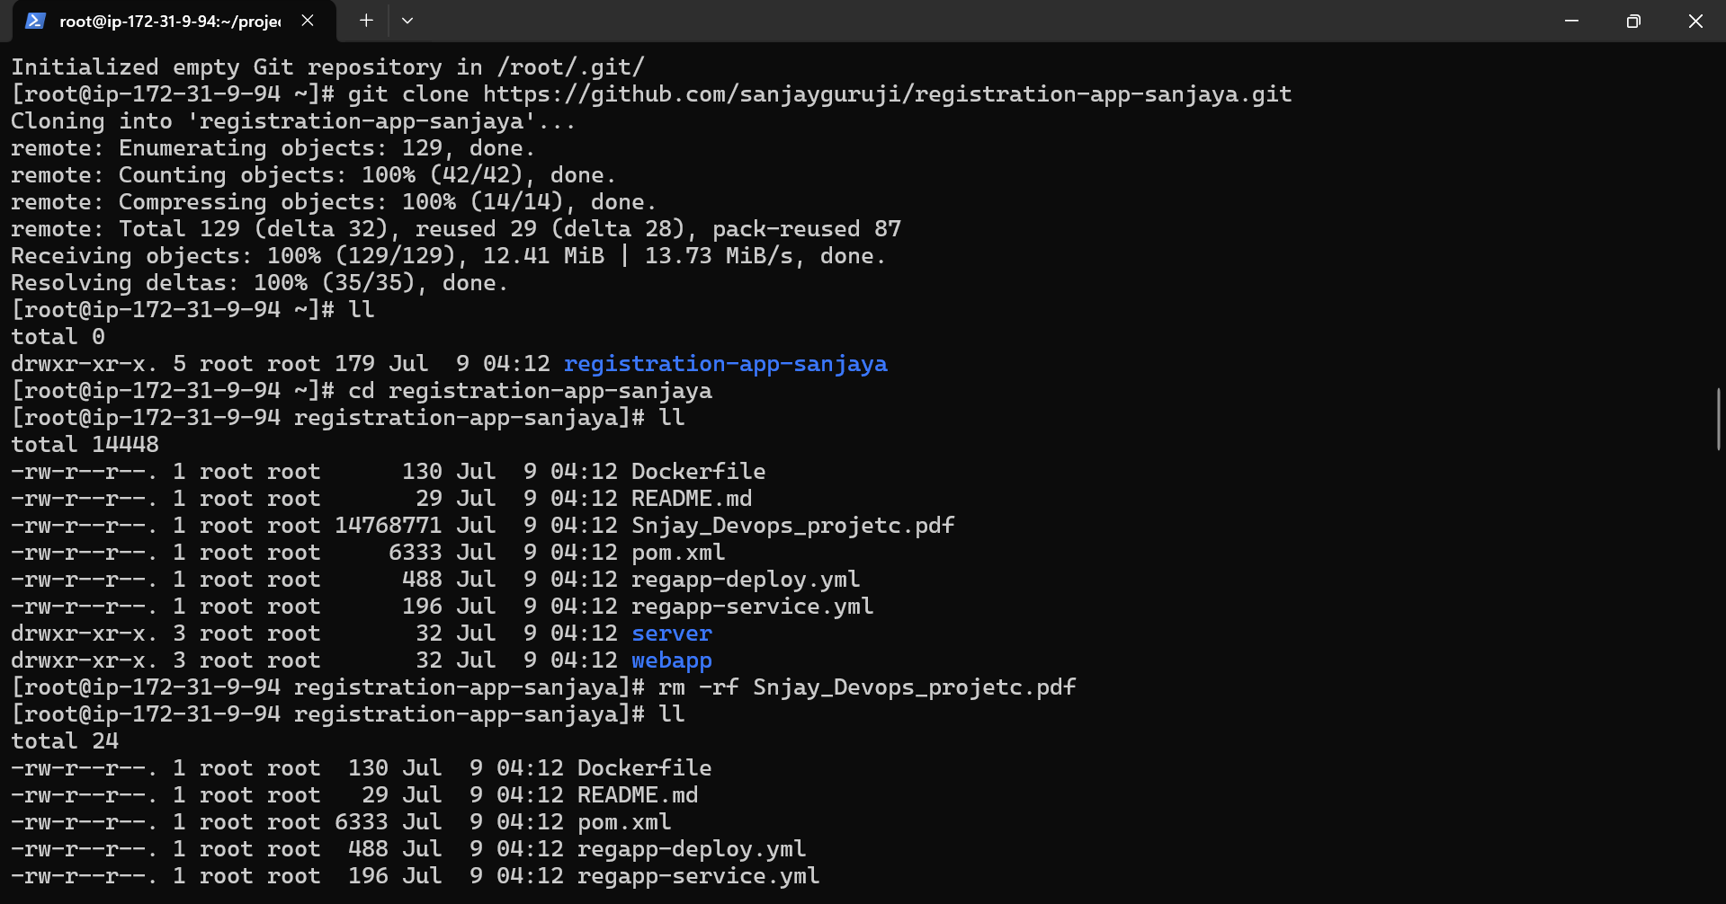

Repository has been cloned from GitHub.

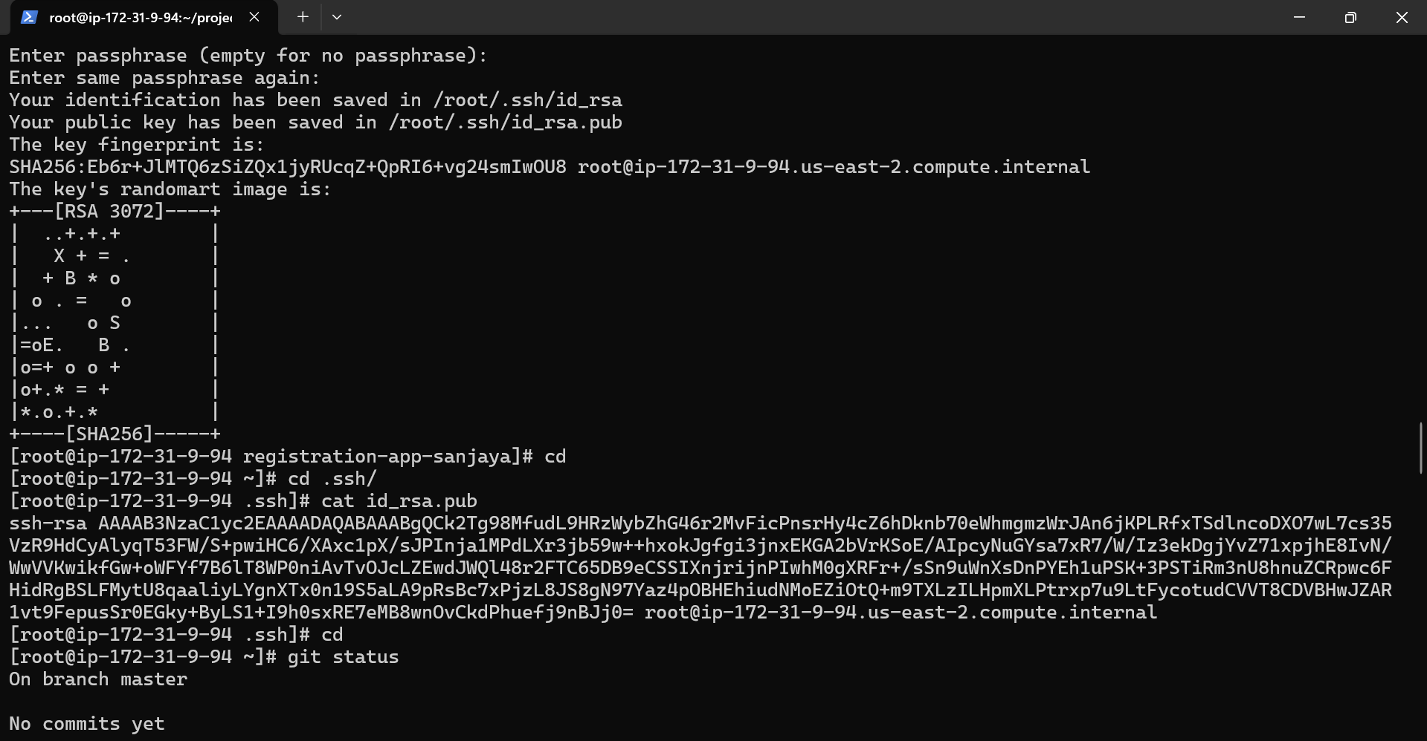

SSH key is generated for connection with GitHub for pushing it my GitHub.

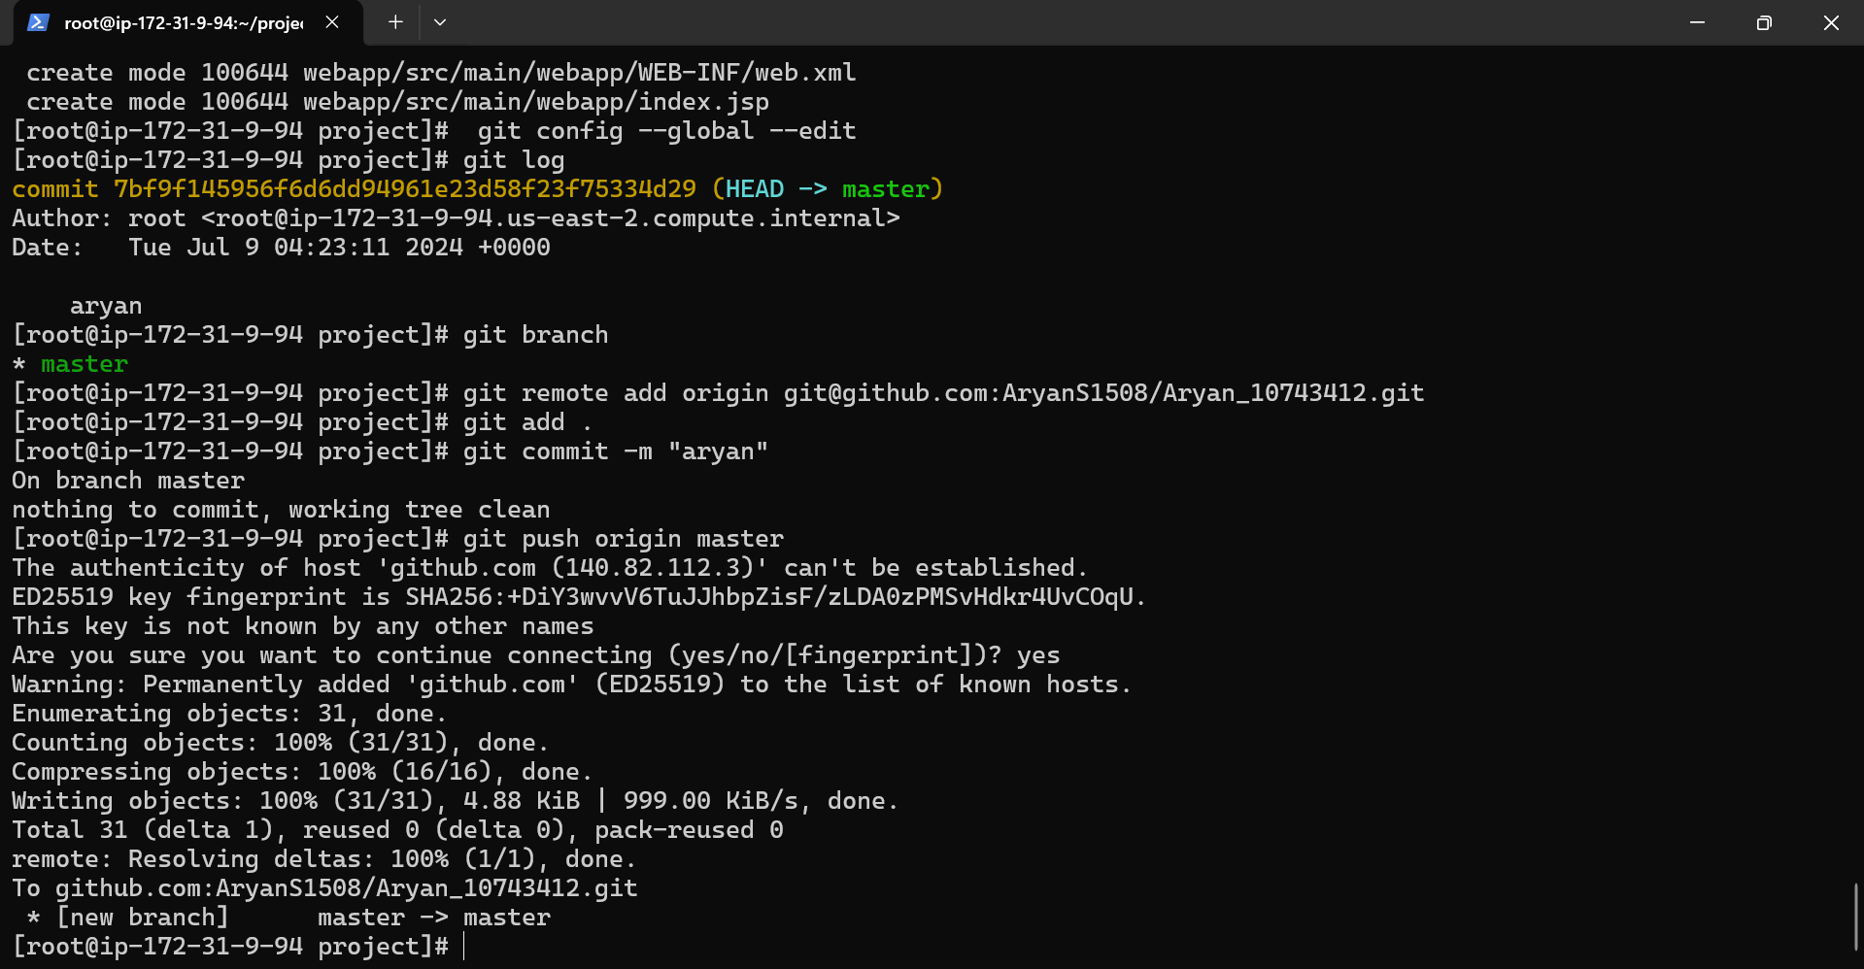

Here the remote origin has been given.

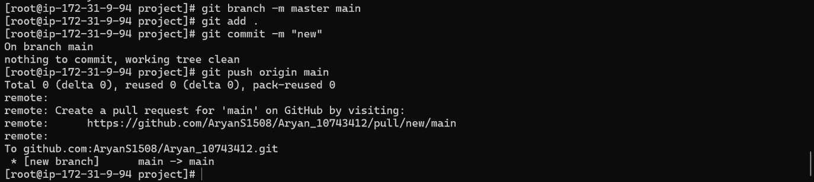

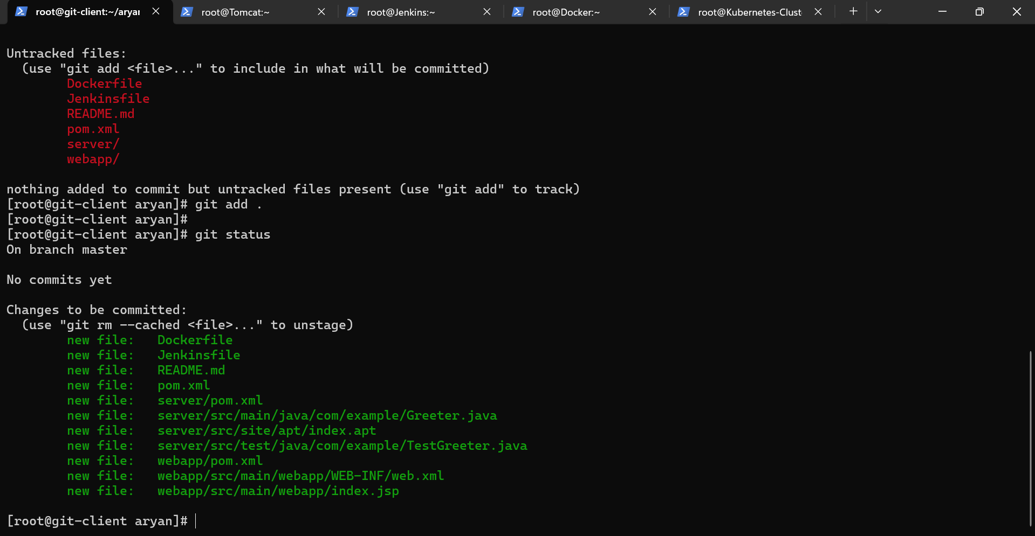

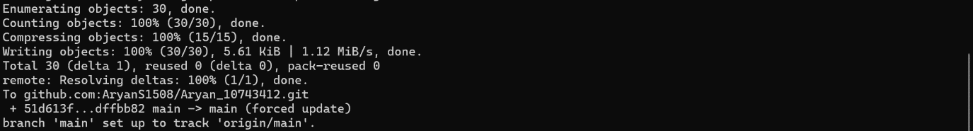

The file is added and commited and are ready for pushing in the github Repository.

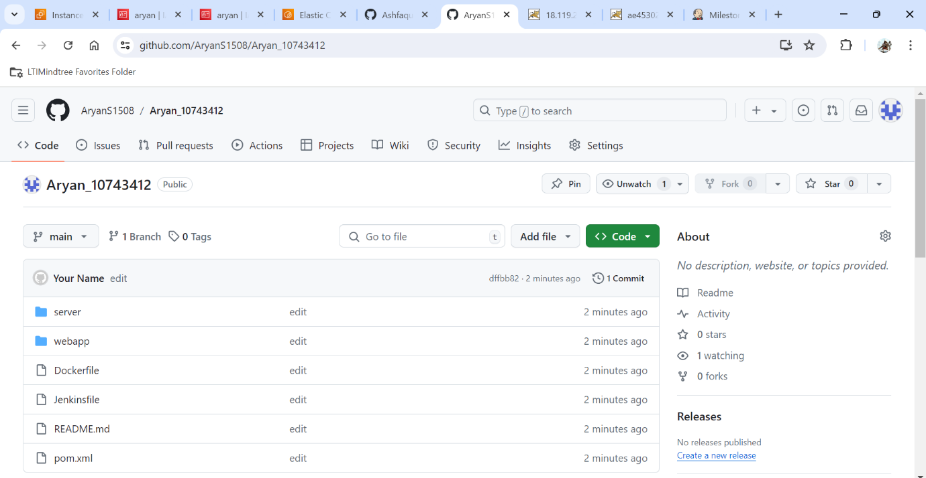

All the files are present in my Github Repository.

Jenkin & Maven :

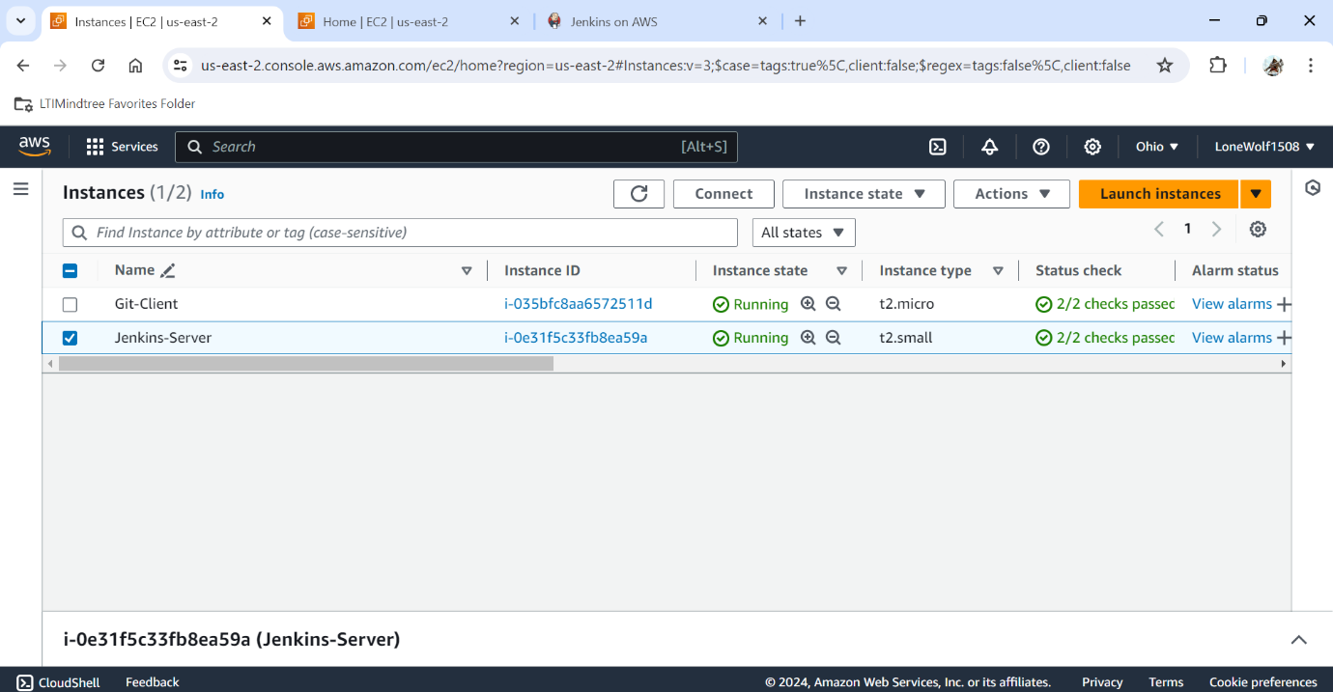

Instance is created for Jenkins.

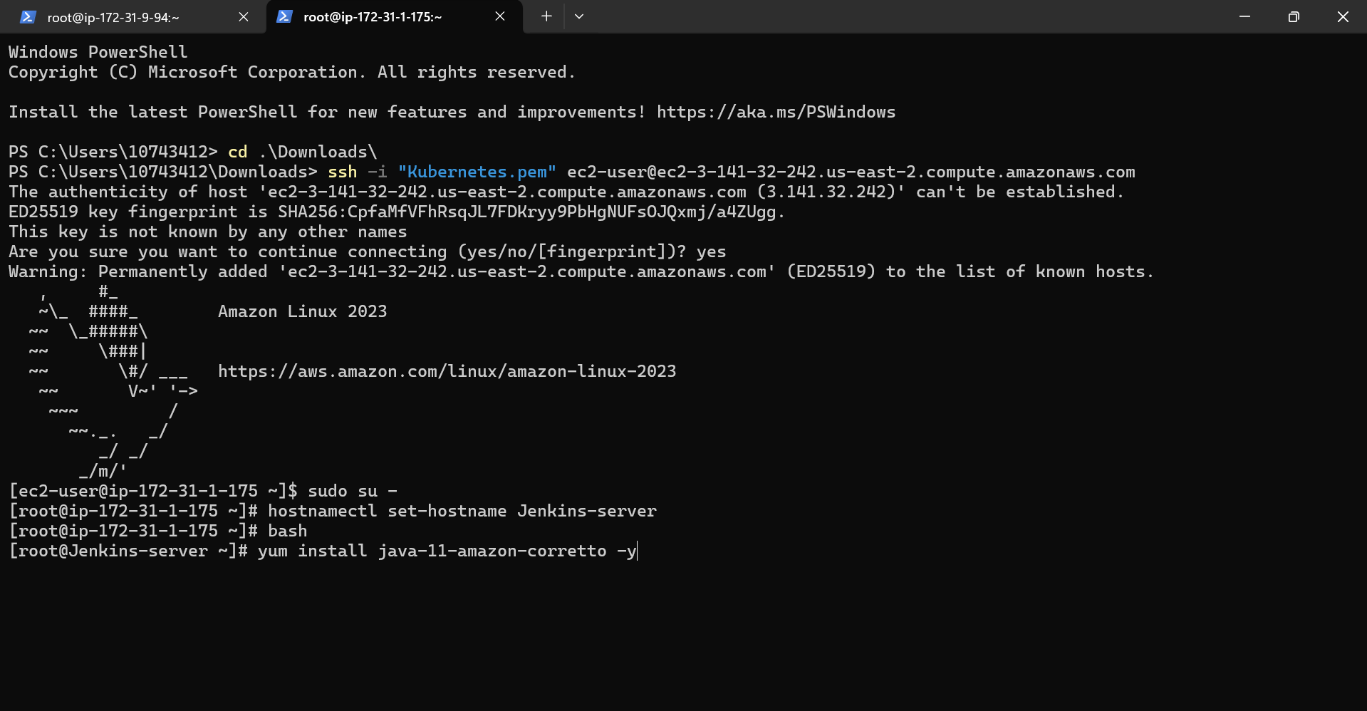

Instance is connected in the Terminal.

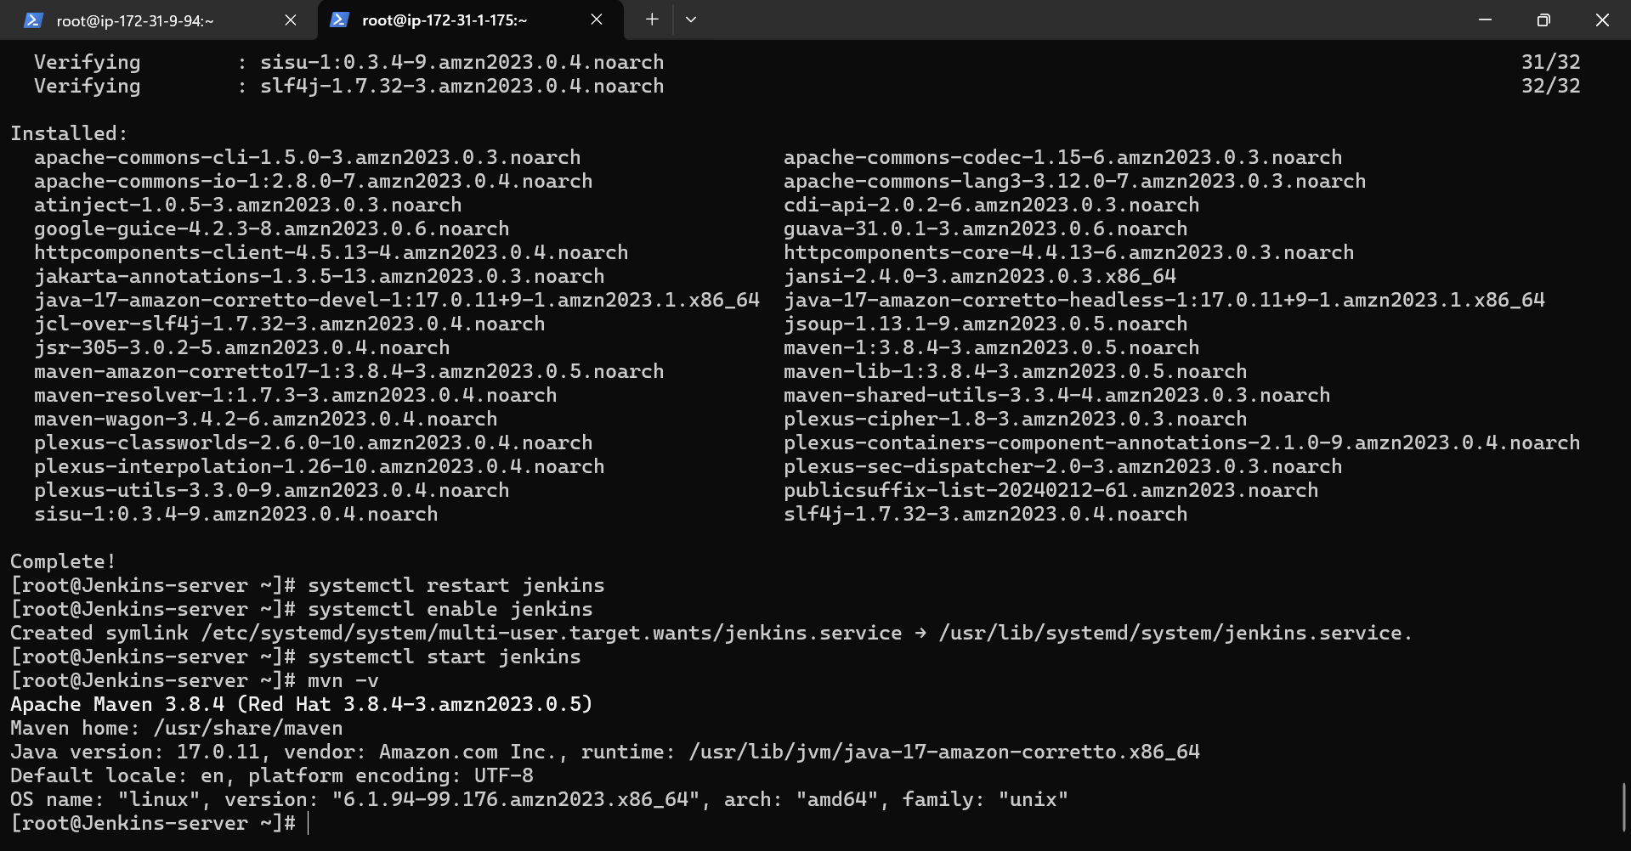

Java and Jenkins has been installed.

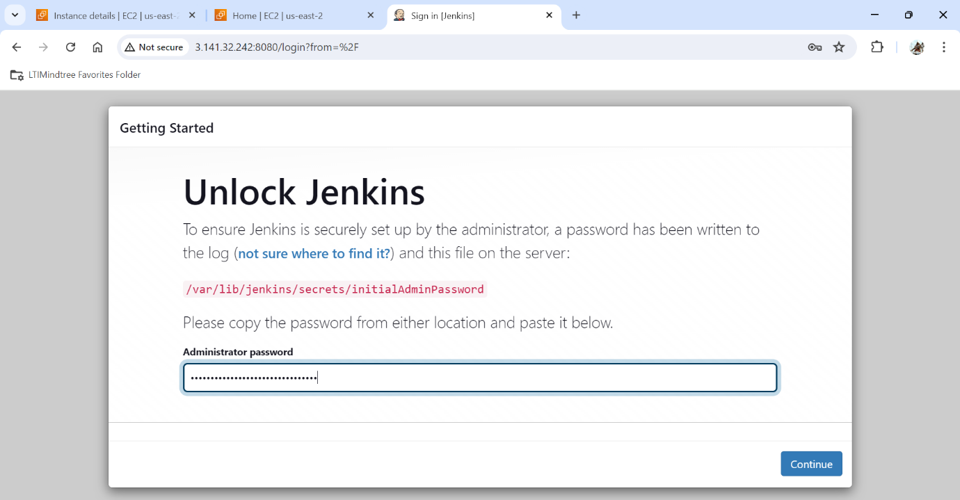

Jenkins has been unlocked.

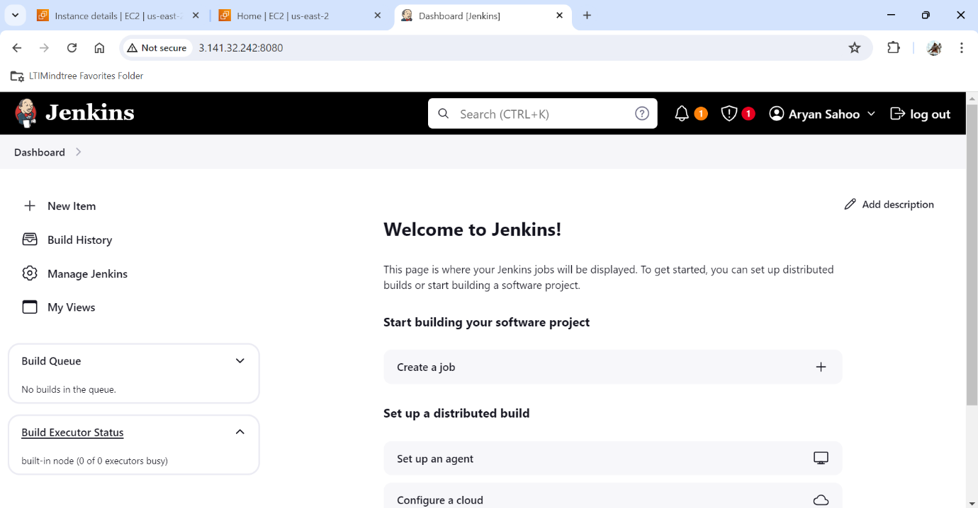

Jenkins has been connected in the Web Browser.

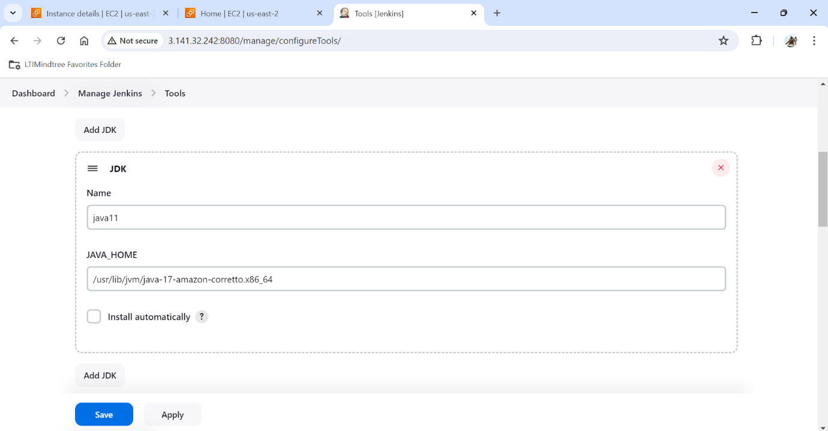

Java path has been given now.

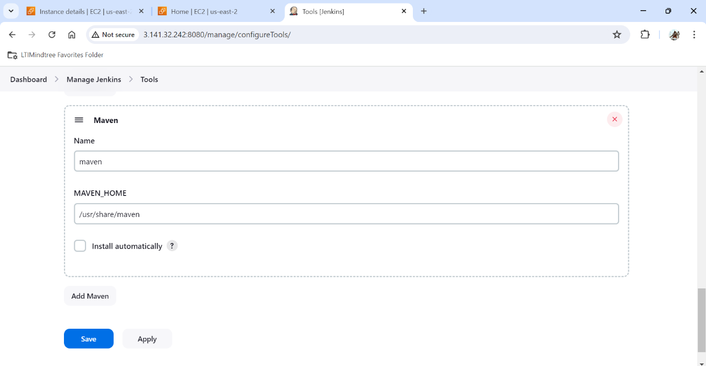

Maven path has been given now.

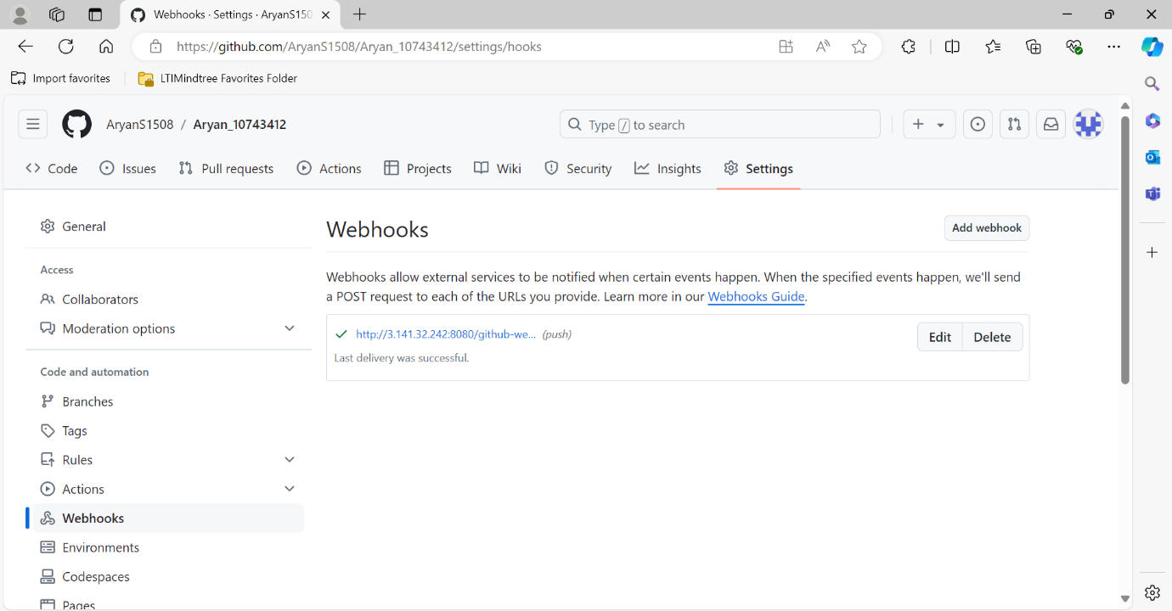

Webhook is created for connection of my Github Repository and Jenkins.

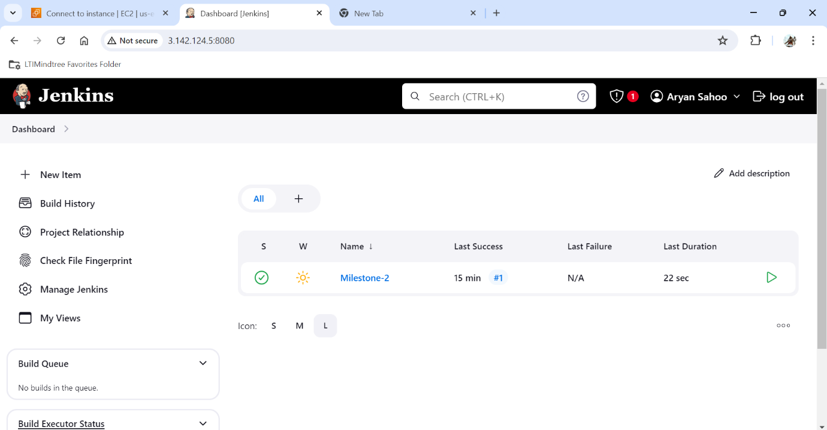

Now the job is build.

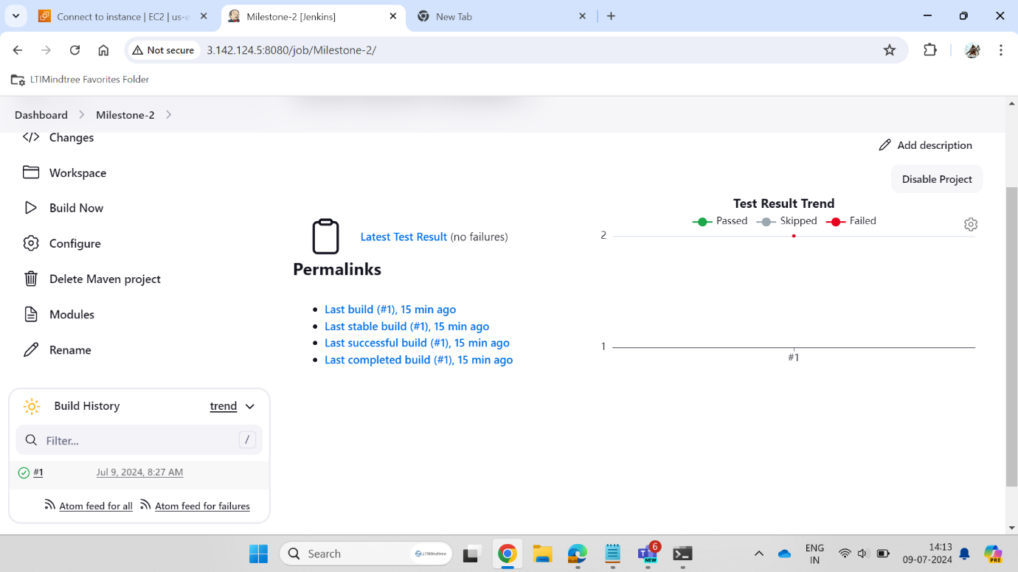

Test Result is shown here.

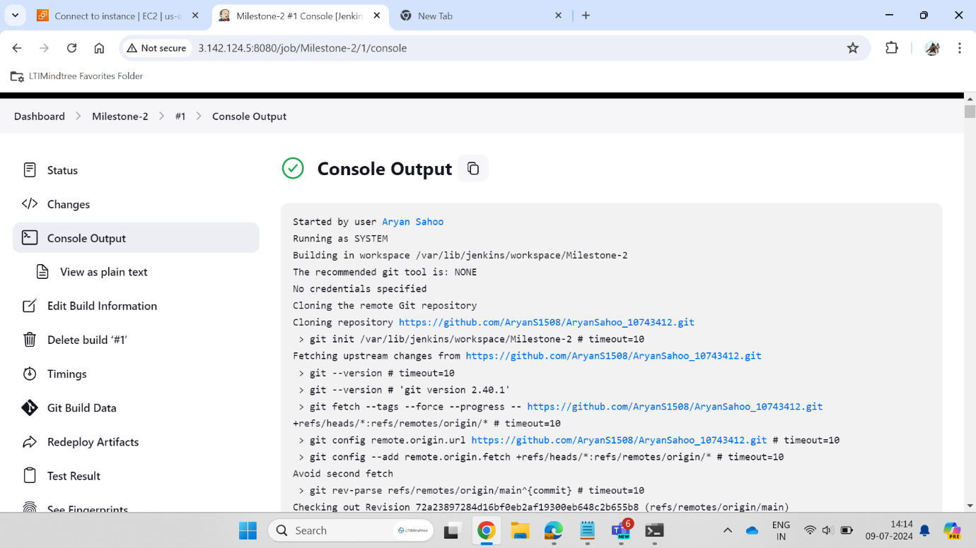

Console output is diplayed here.

Tomcat :

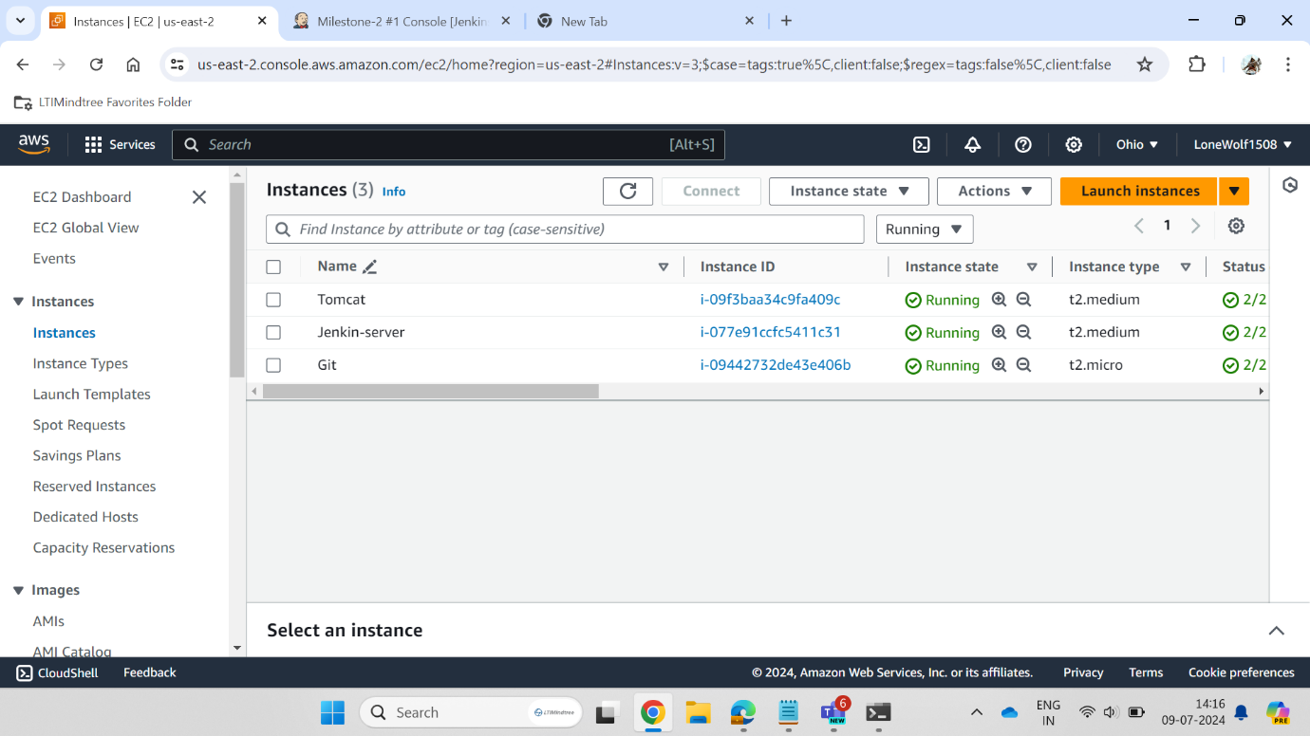

Instance for Tomcat server is created.

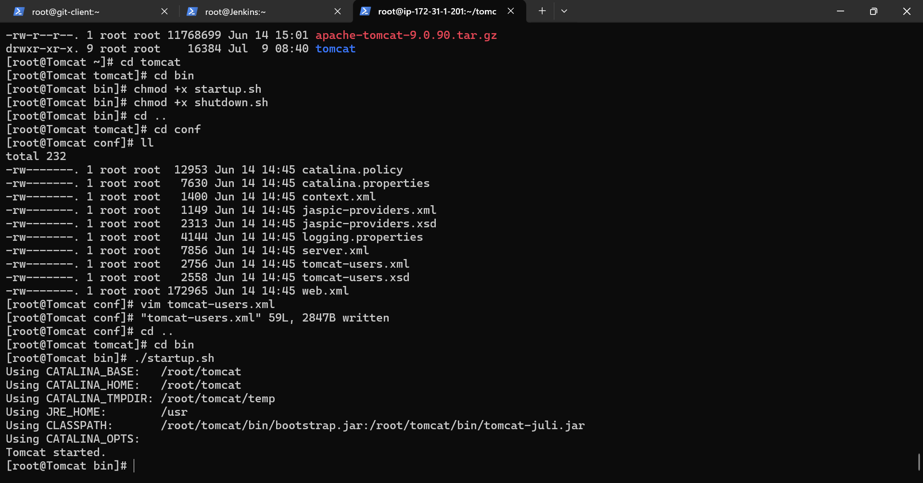

Instance is connected in the Terminal.

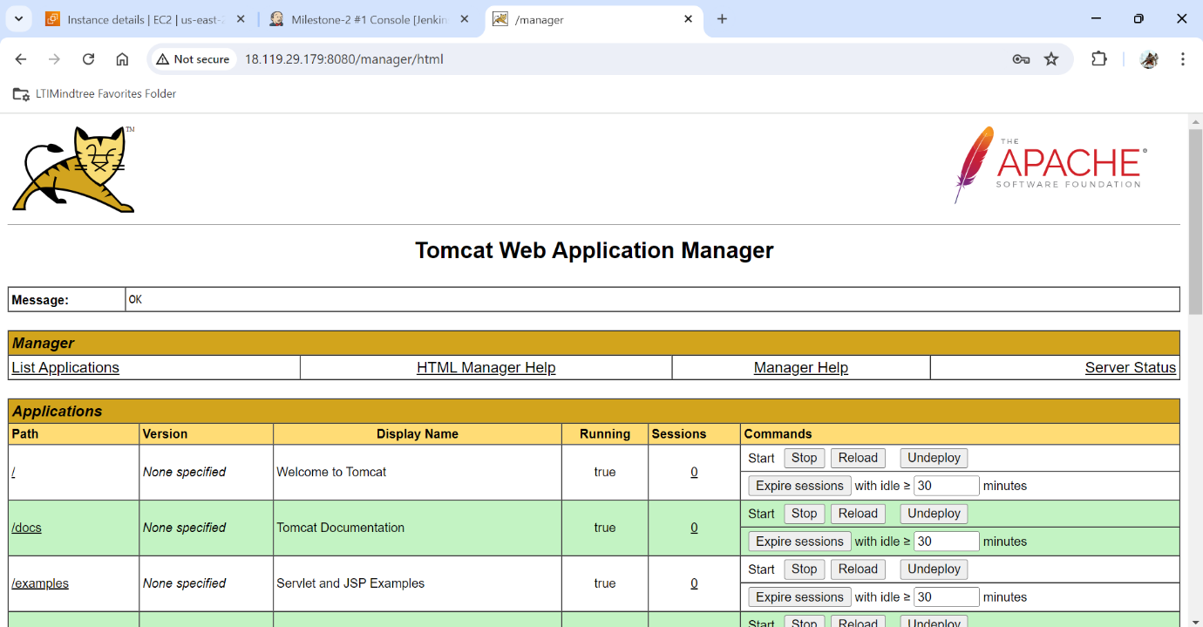

Tomcat admin has been logged in manager controls.

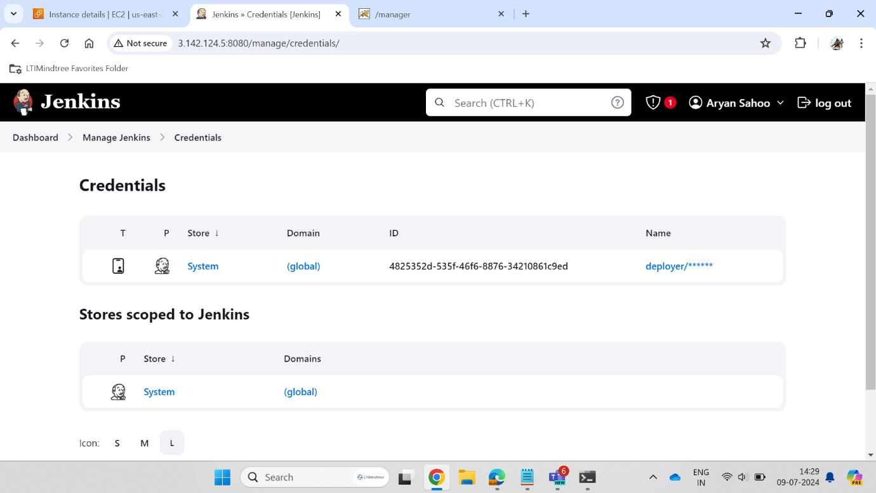

Global credentials has been created for the tomcat server.

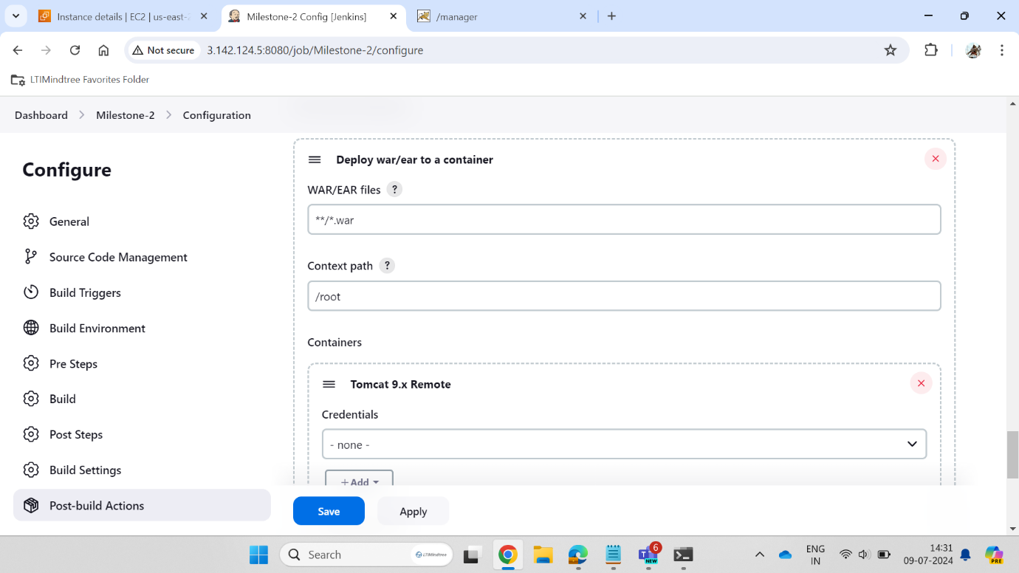

We are creating .war file for tomcat server.

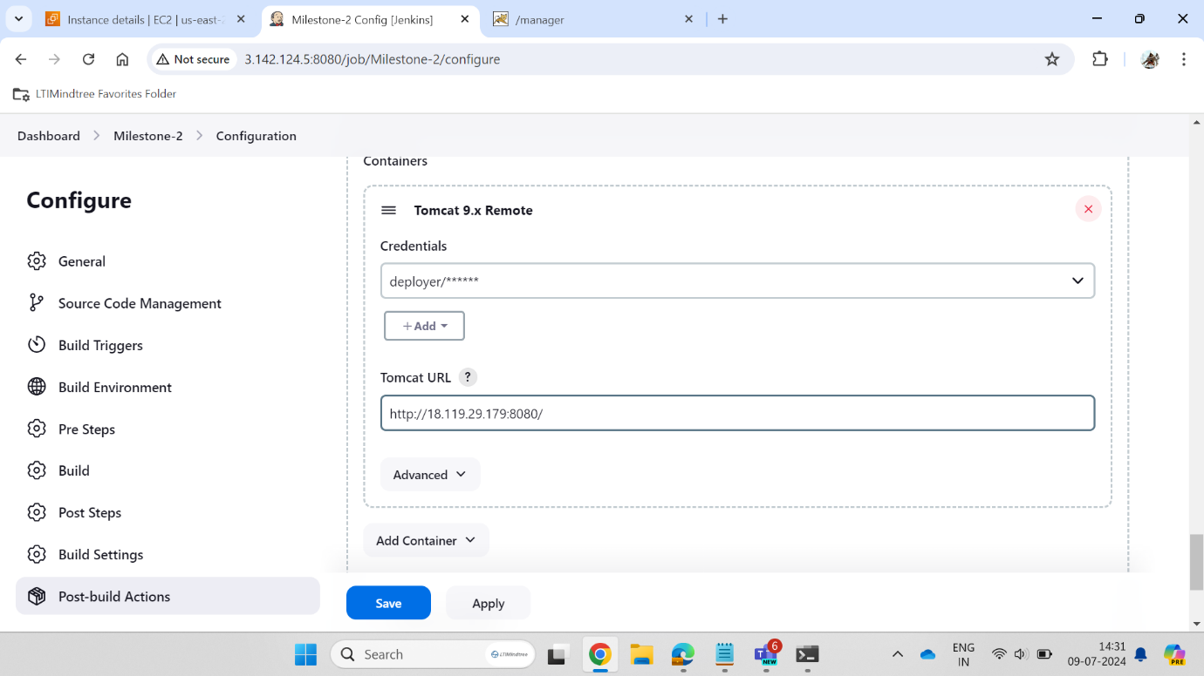

Tomcat url has been given in the Jenkins.

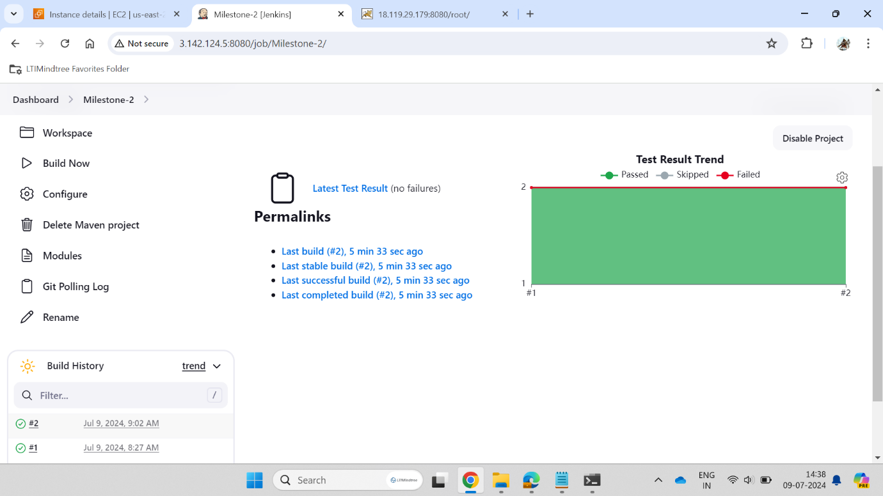

Test Result is diplayed after building the job.

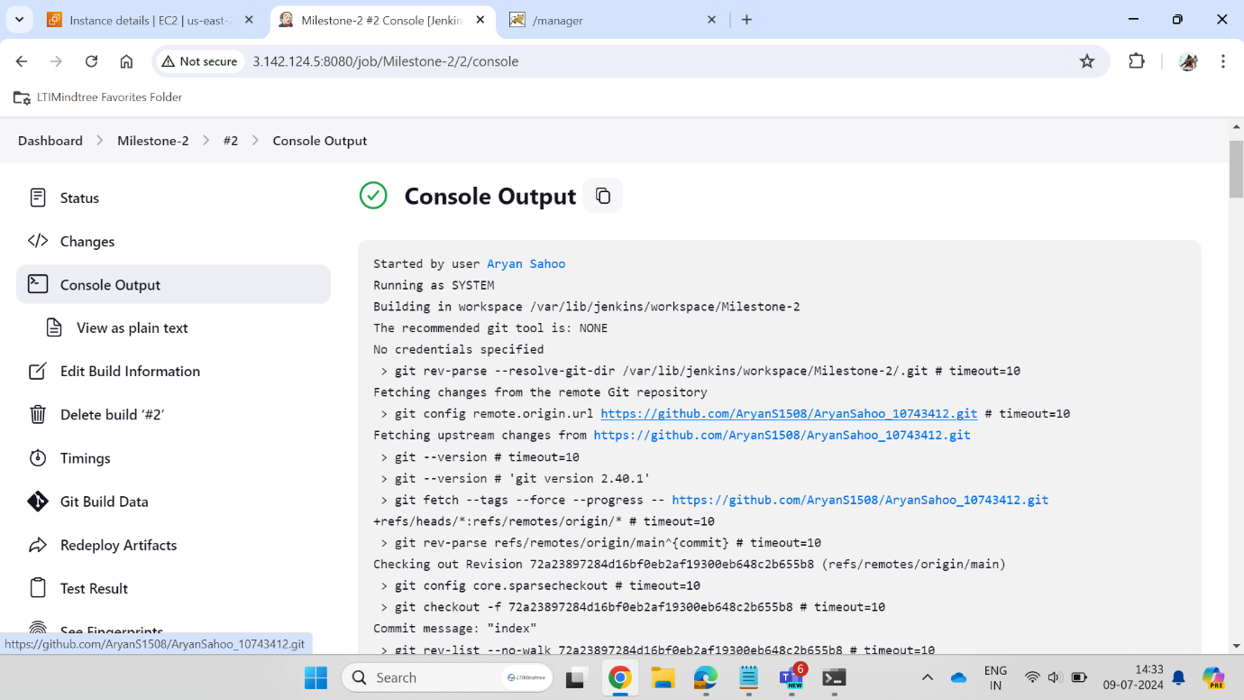

Console output is displayed here.

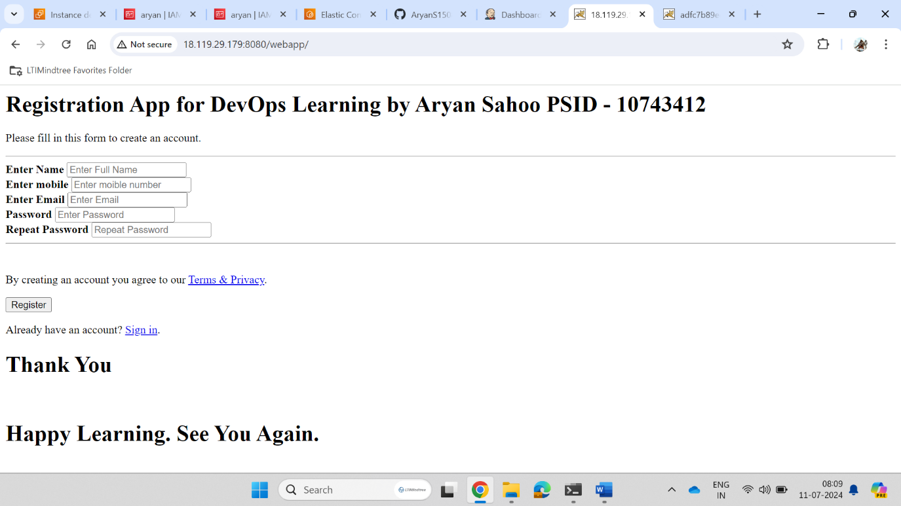

Webpage is hosted in the Tomcat server.

Docker :

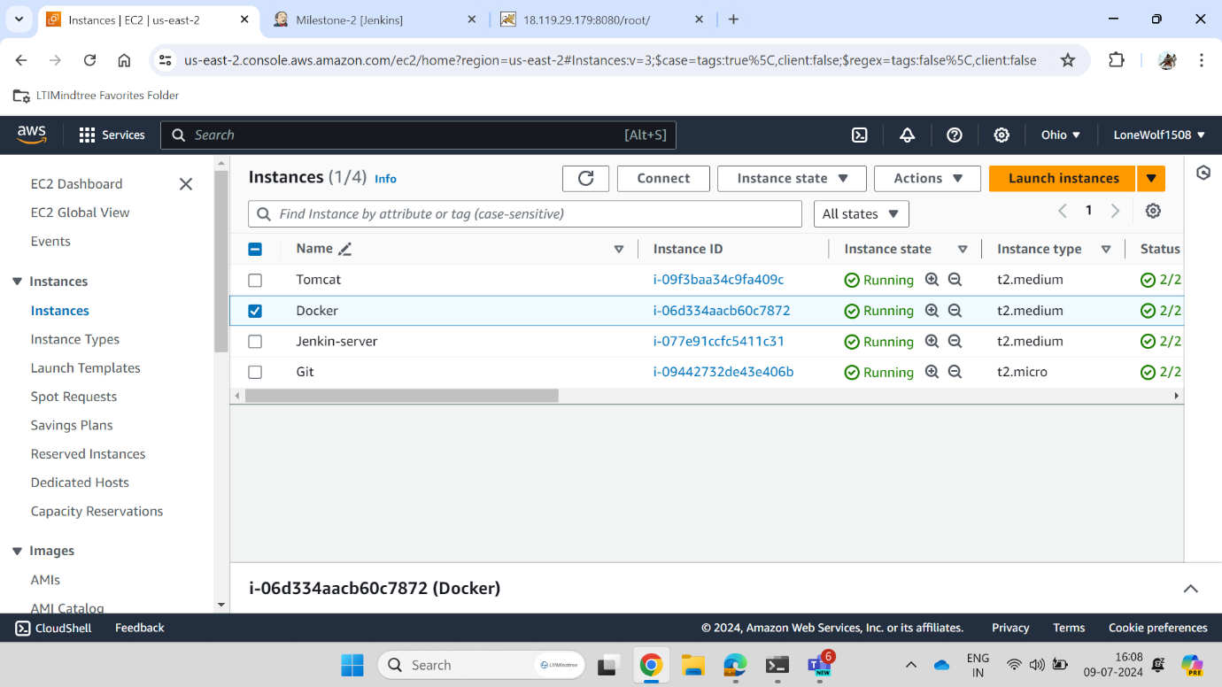

Instance for Docker is created.

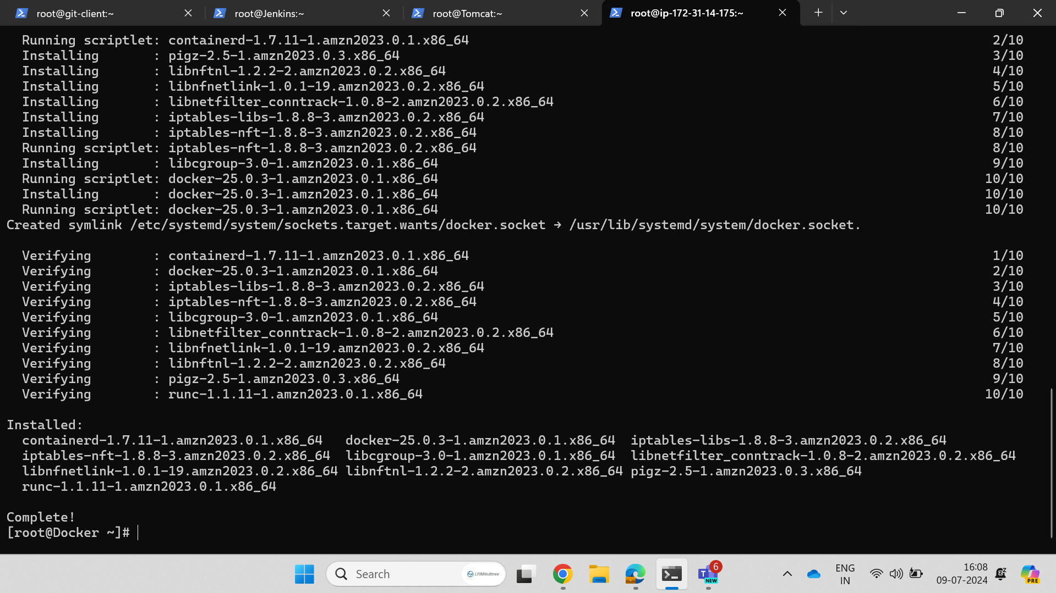

Instance is connected in the Terminal.

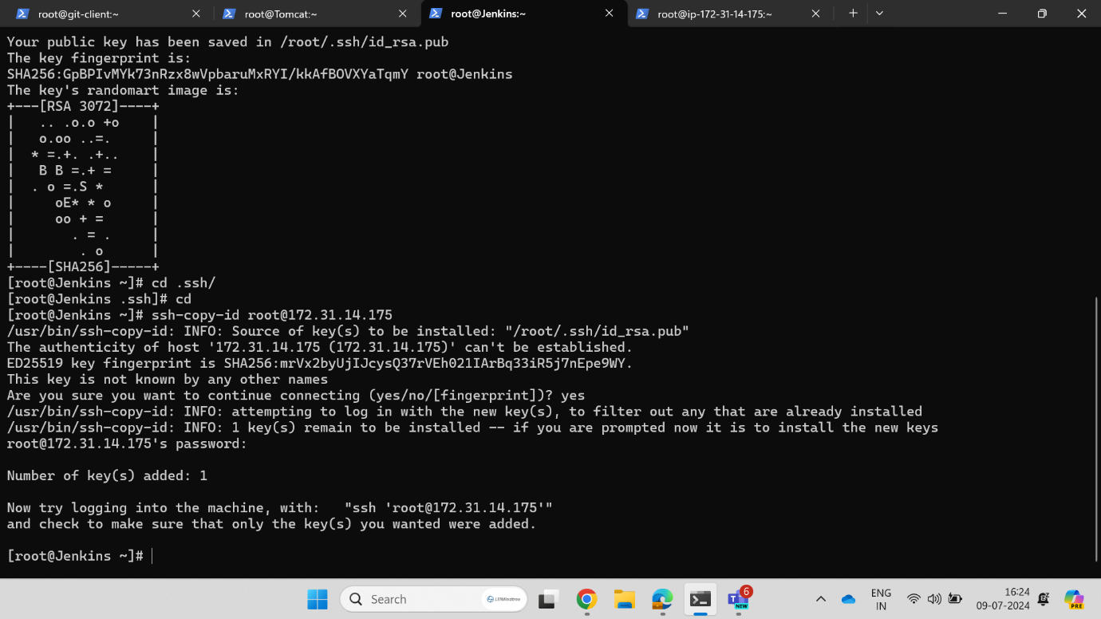

Ssh-key is generated for connection.

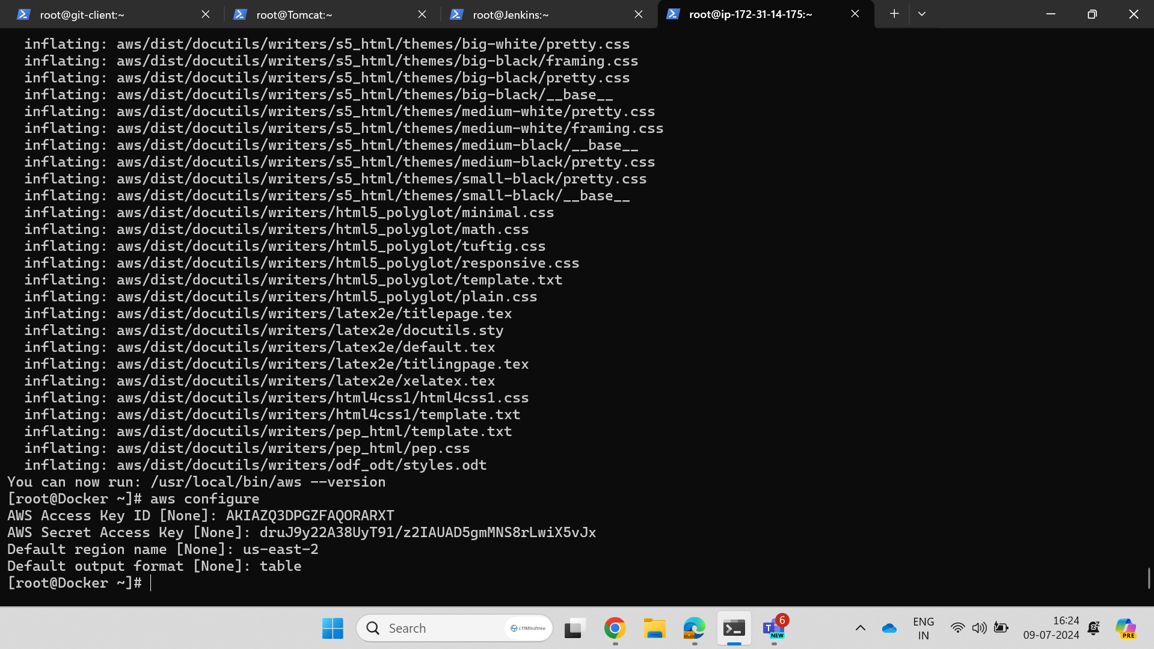

Aws user has been configured here.

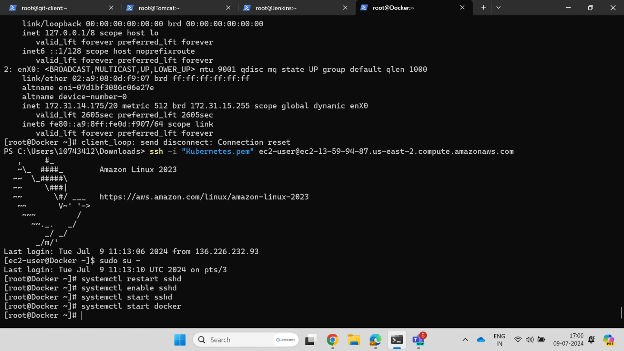

Sshd has been restarted after giving the permisions.

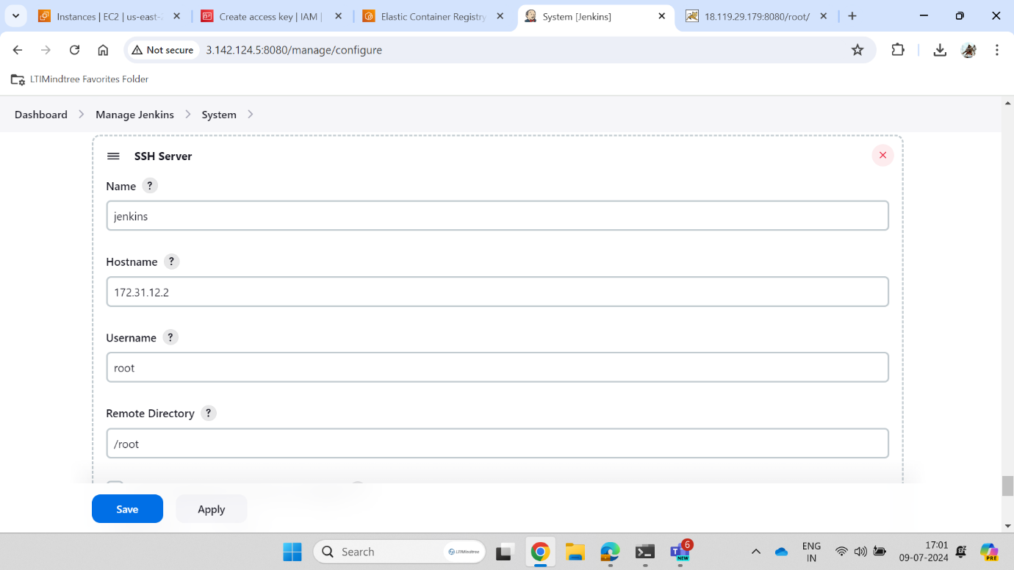

Jenkins has been connected with the SSH Server in Jenkins.

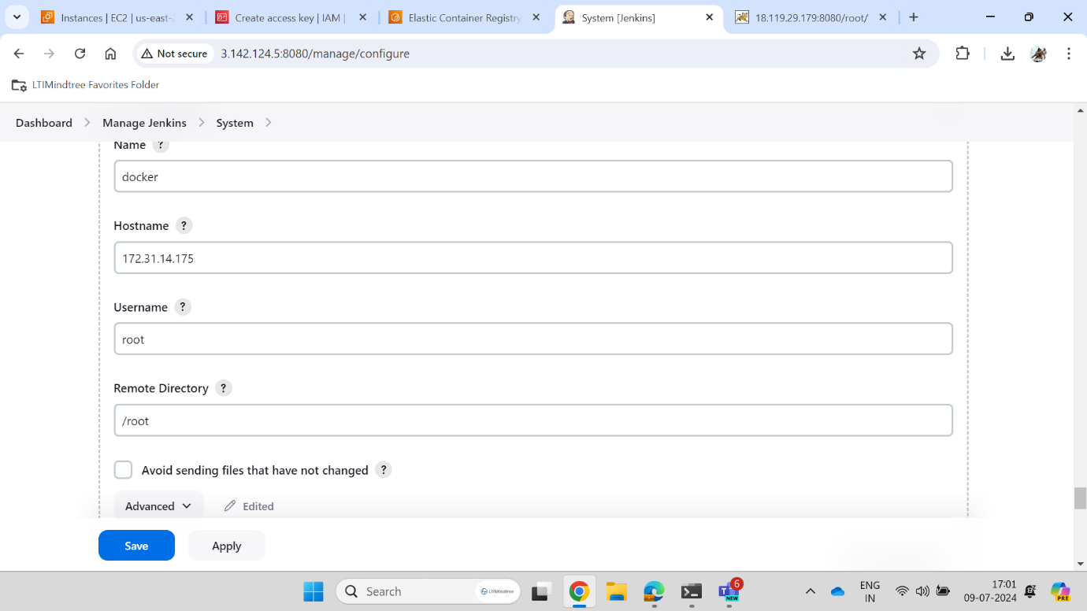

Docker has been connected with SSH Server in Jenkins.

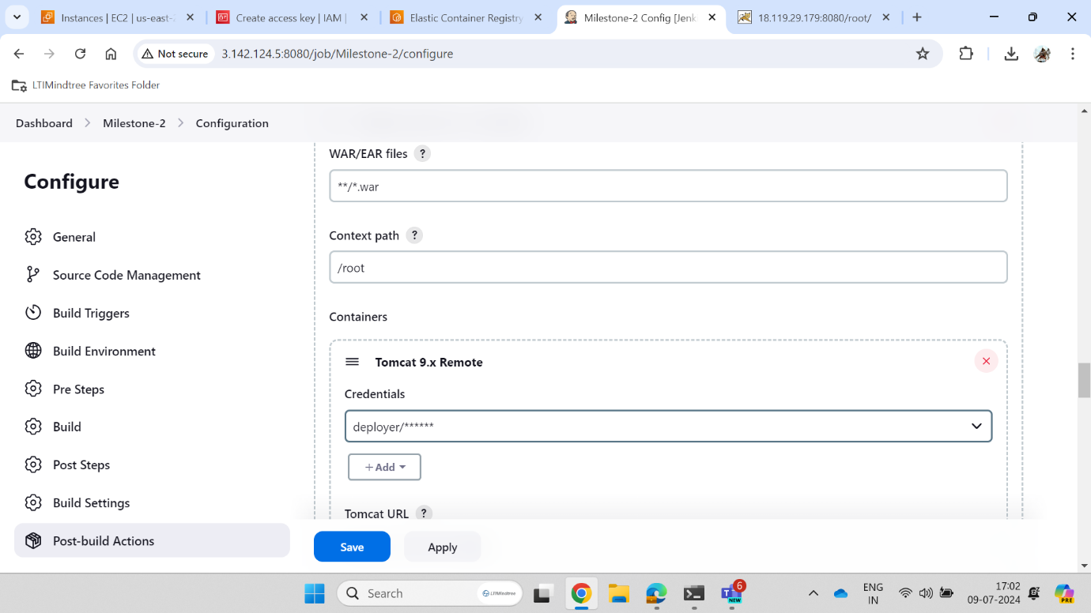

Here .war file is created for tomcat.

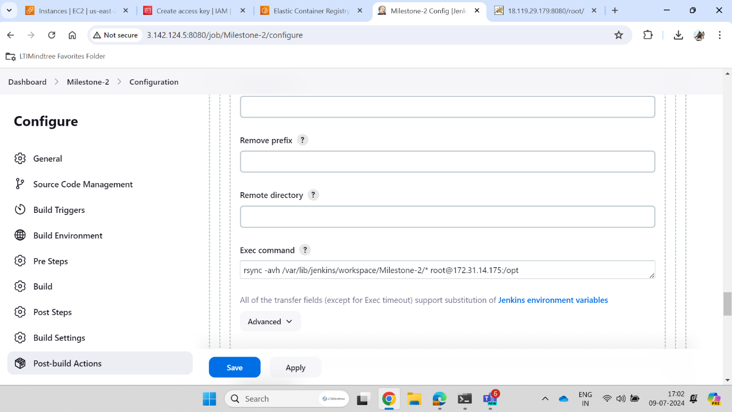

In project configuration we are connecting Jenkins with docker by providing docker IP.

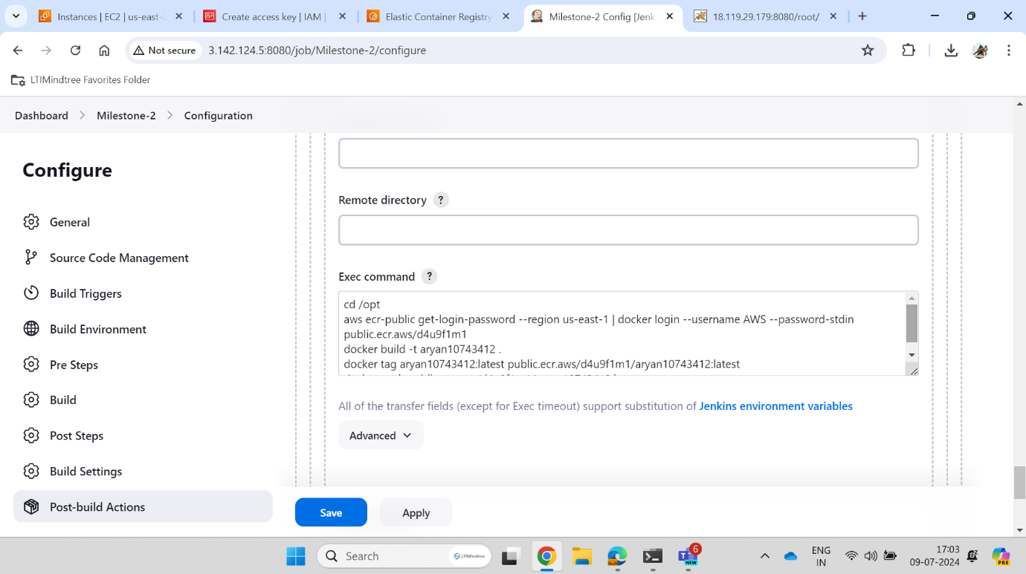

Here the commands has been given for creating the image inside the docker.

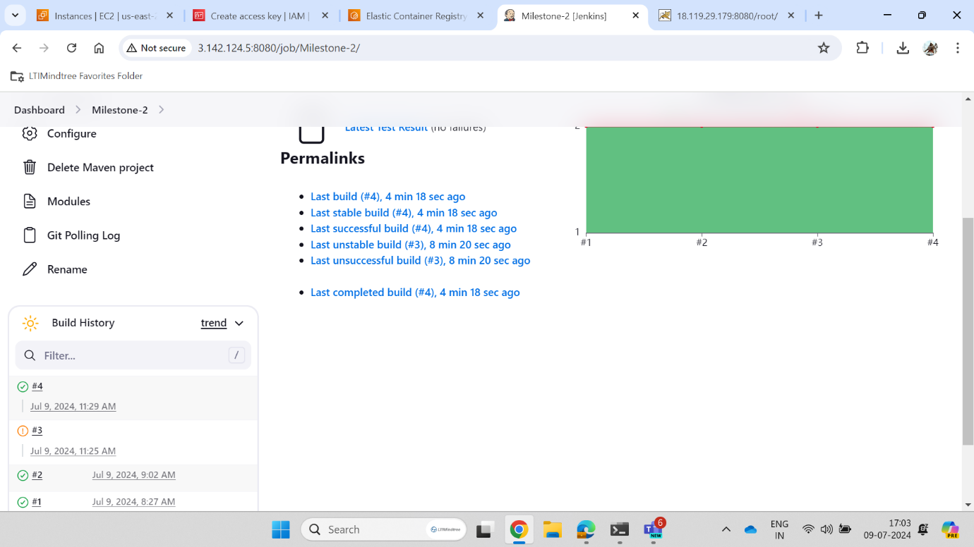

The project has been built and the Test Result is displayed.

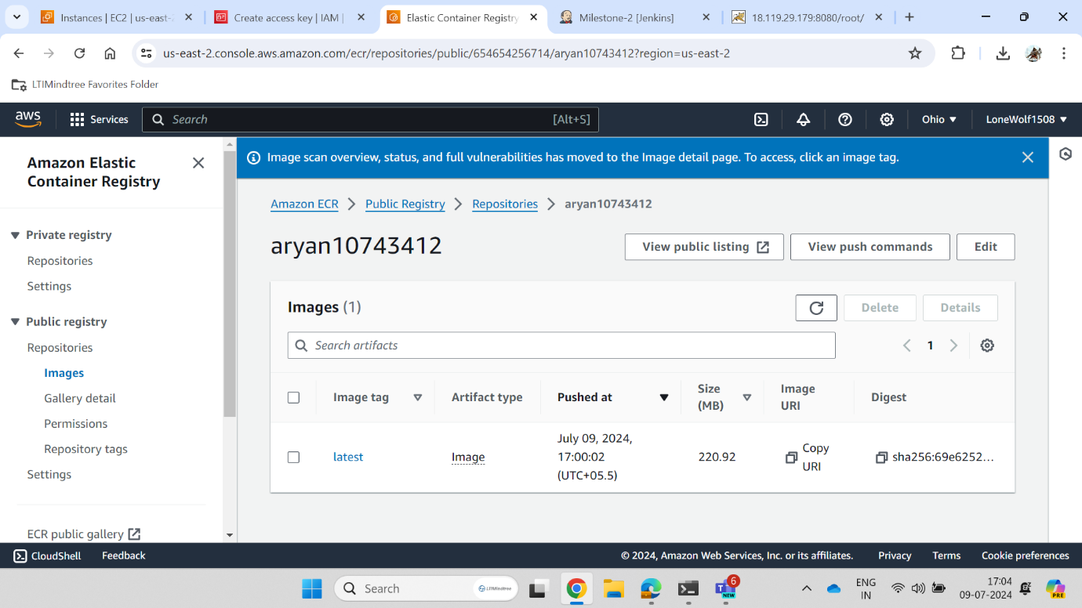

Here the image has been created in the docker.

Kubernetes EKS :

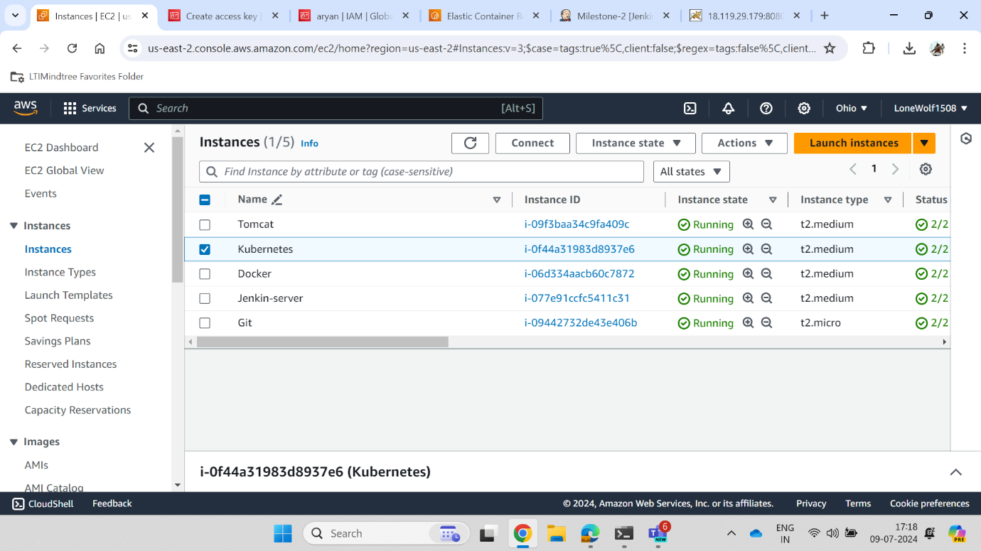

Instance for Kubernetes is created.

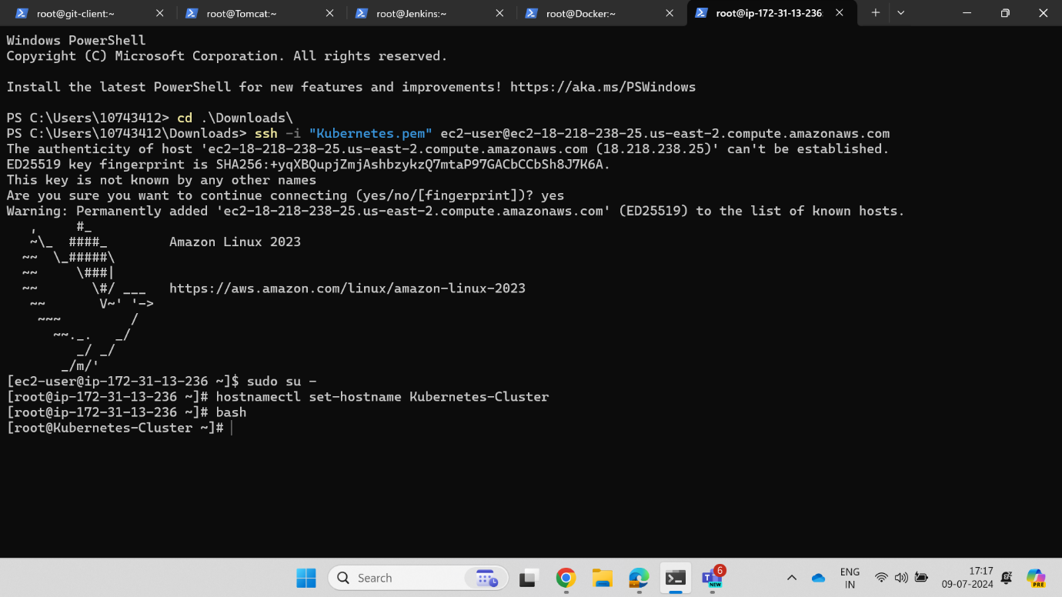

Instance is connected in the Terminal.

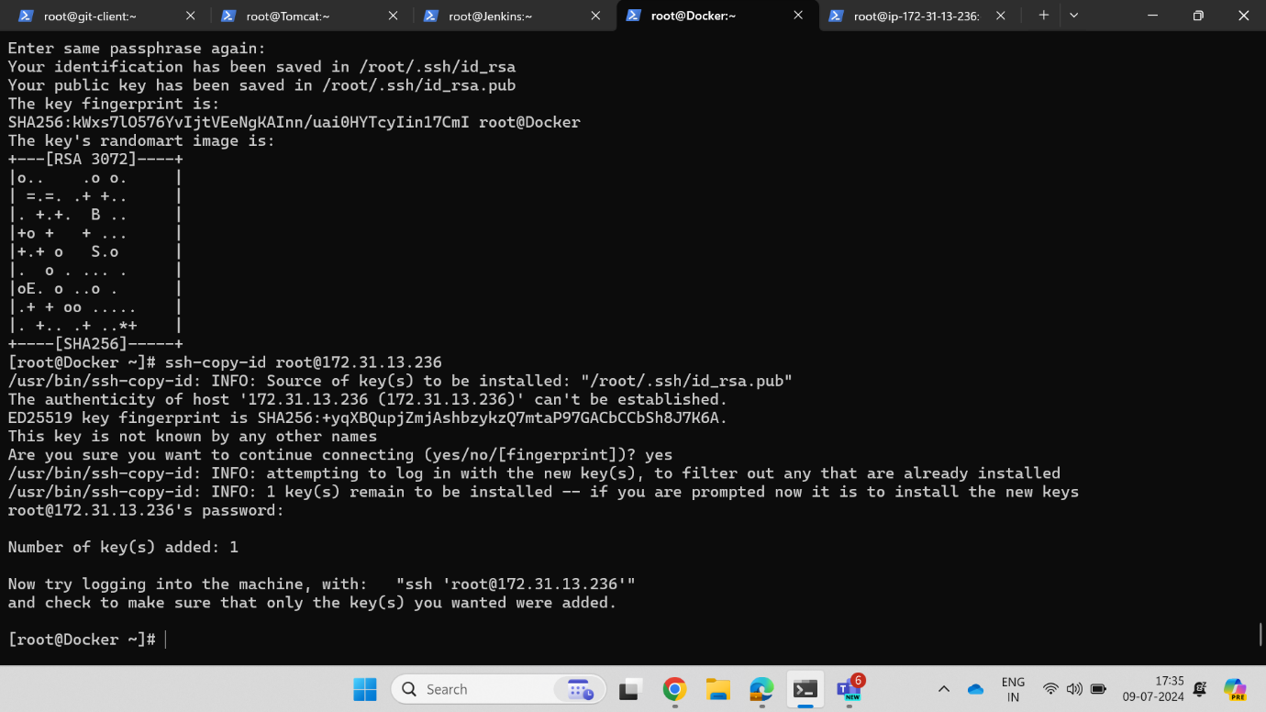

Ssh key is generated aand connected with the docker instance.

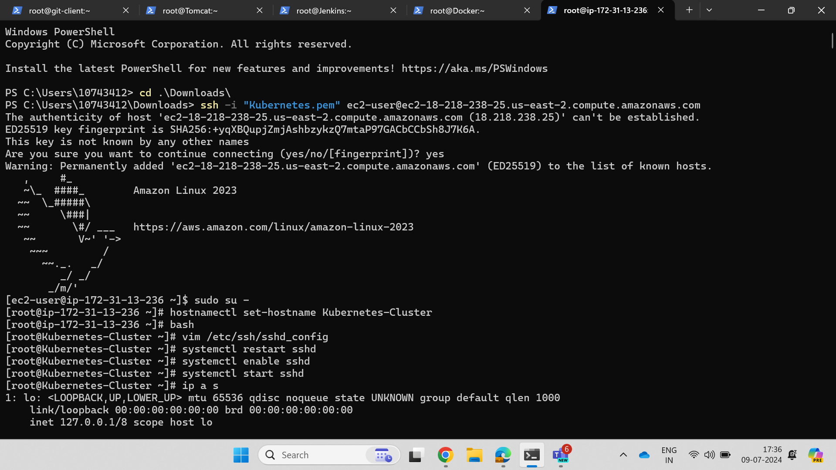

Sshd is restarted after giving the permissions.

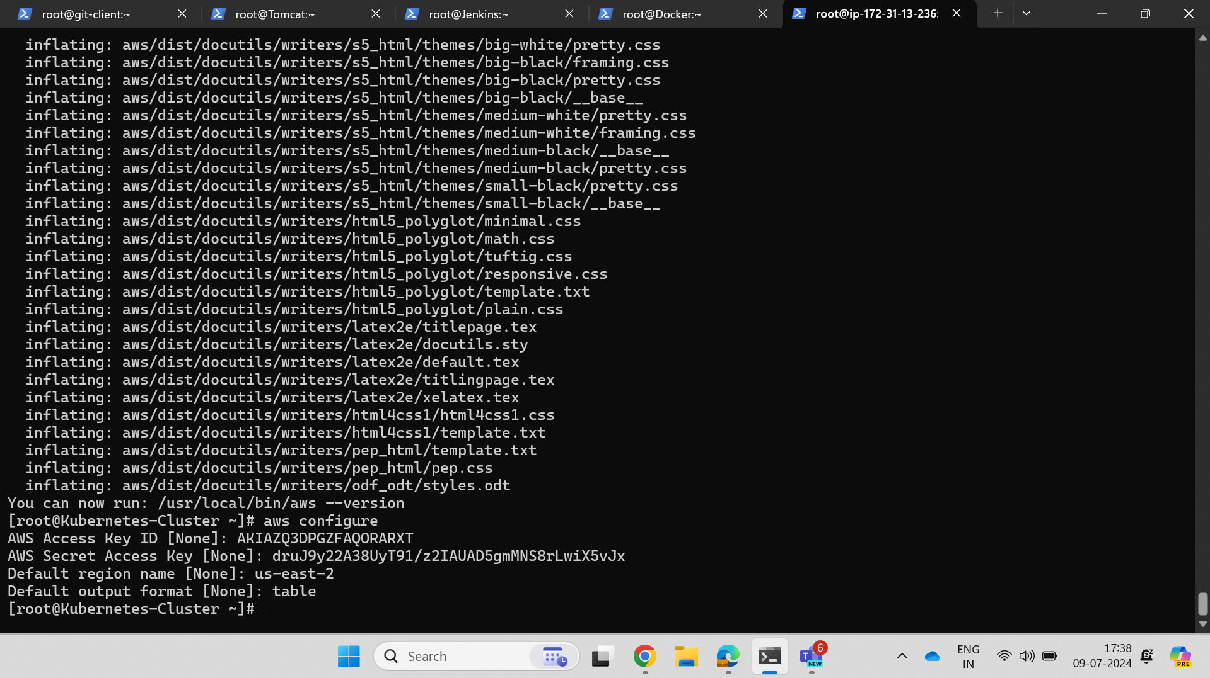

Aws user has been configured here through access key and secret key generated in the Aws console.

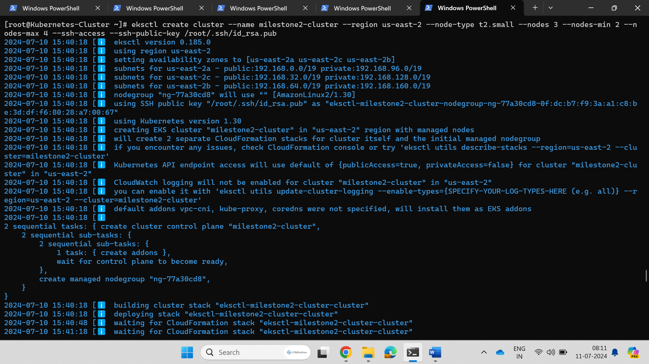

Cluster is getting created with name, region, type, nodes and ssh-key.

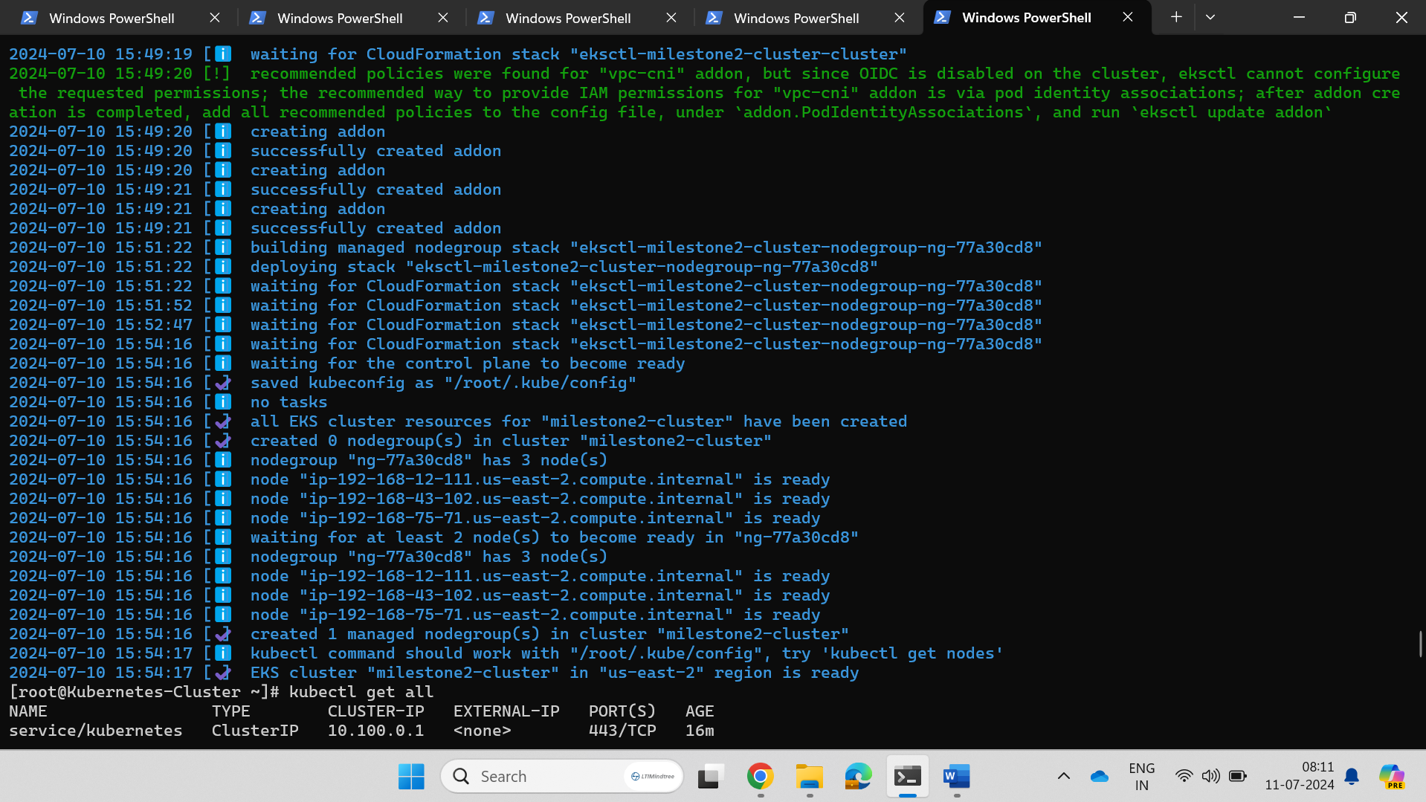

The cluster has been created here.

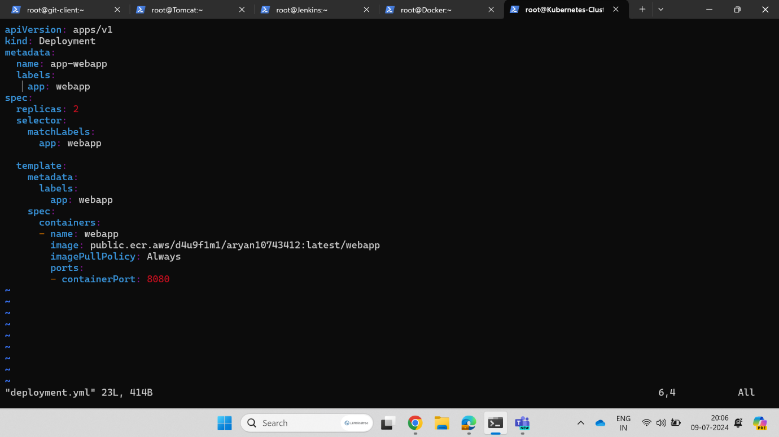

Content which has to be written in the deployment.yml

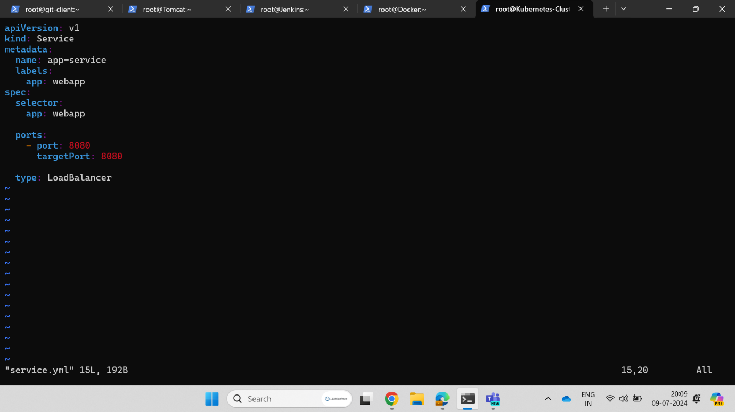

Content which has to be written in the service.yml

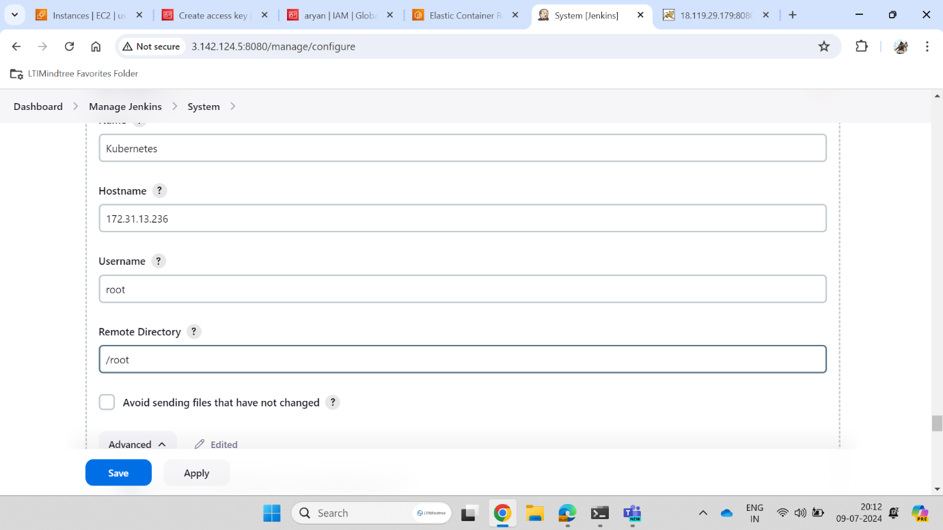

Kubernetes has been configured in the Jenkins.

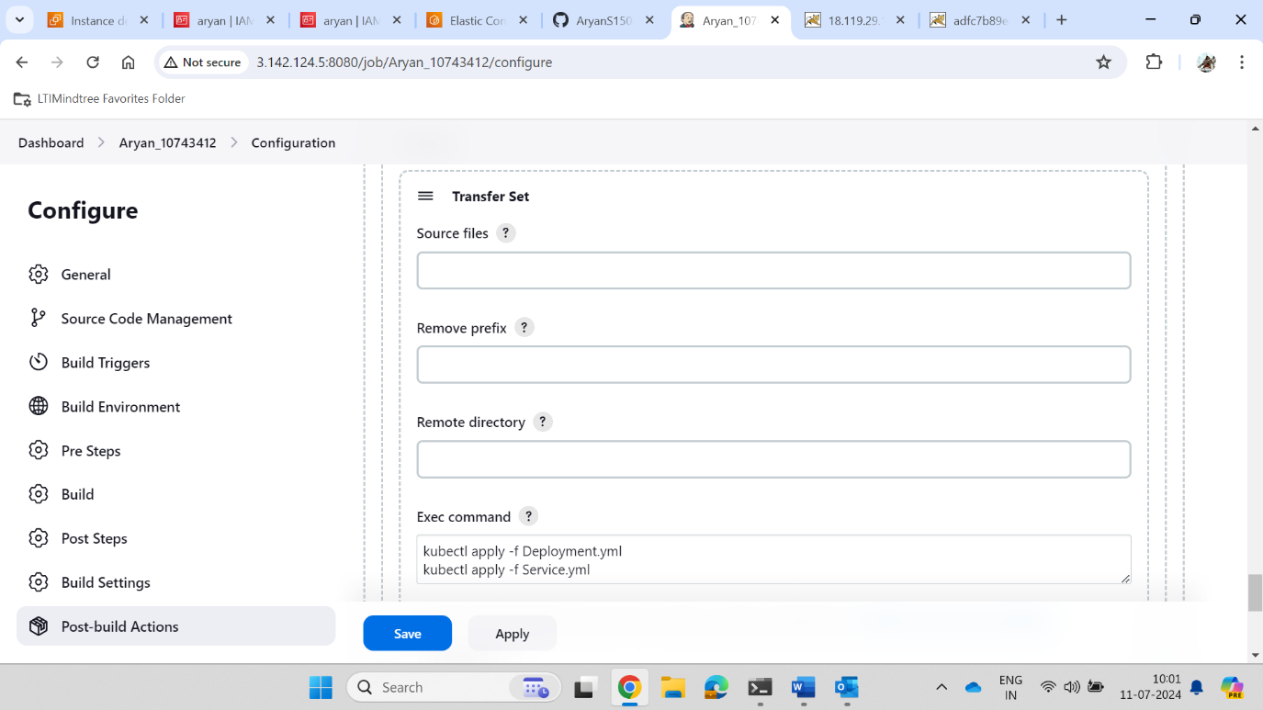

Here the application of Deployment and Service .yml file is done through Jenkins.

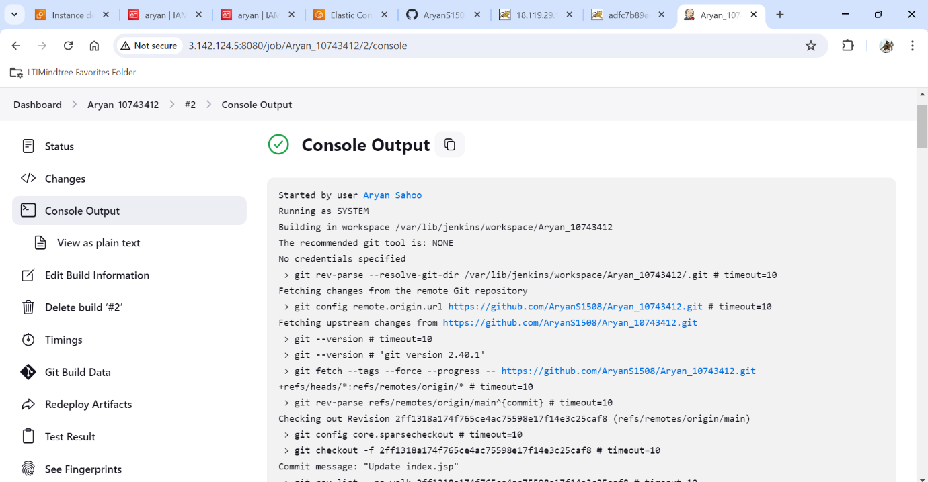

Project has been build and Console Output is displayed.

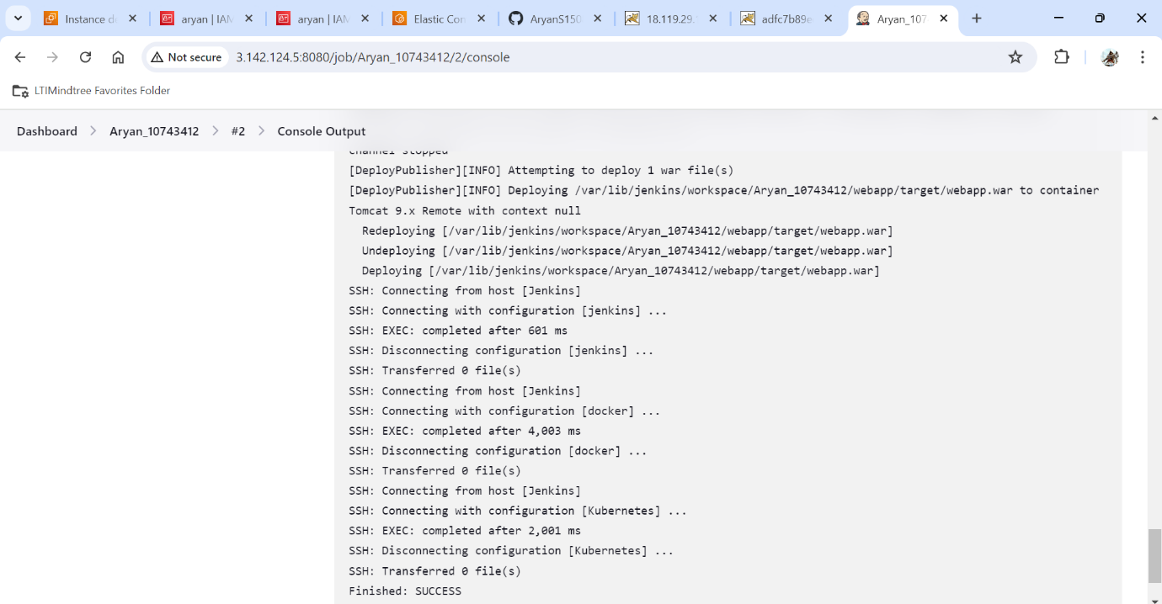

The build was successful.

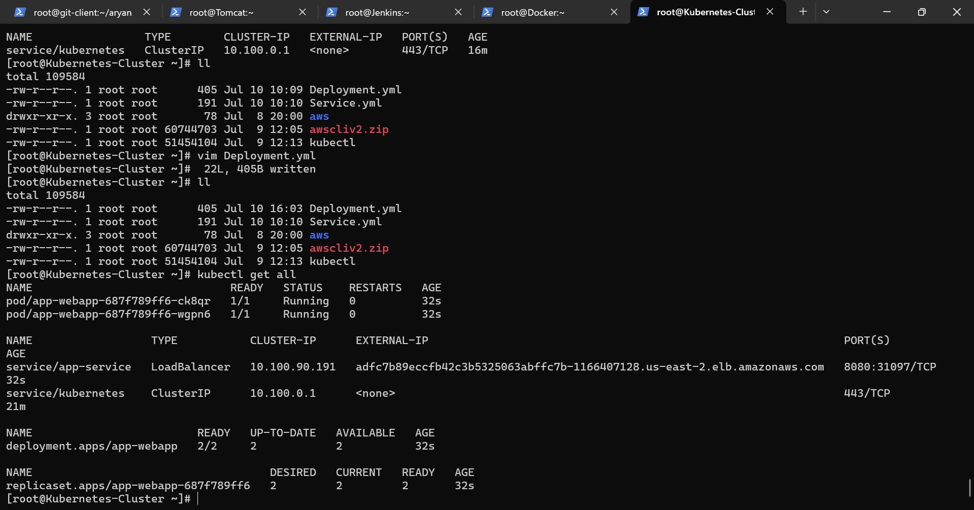

Nodes, Pods, and Service ip is shown.

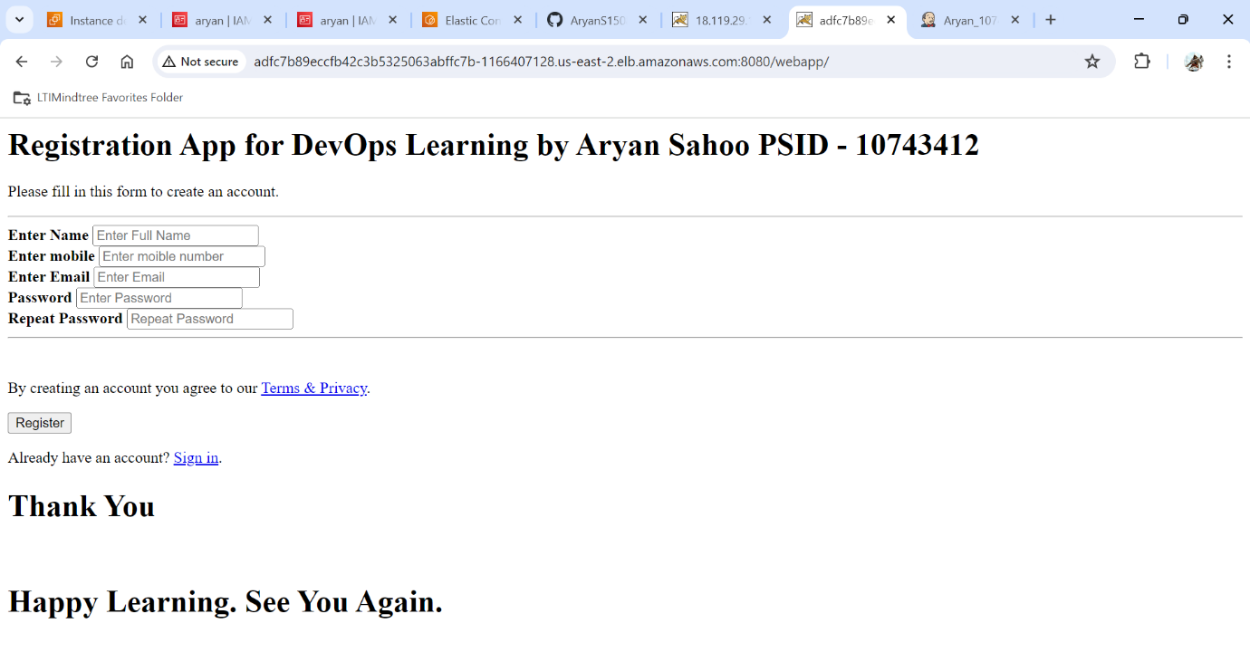

Final output is displayed by taking the servive ip:8080/webapp/ which is being hosting in the Tomcat server.

**By –**

**ARYAN SAHOO**